|  |
| --- |
| colored transparent rectangle  [This Photo](https://www.peoplematters.in/news/employee-relations/80-of-indian-orgs-struggle-to-educate-their-leaders-employees-about-cybersecurity-sophos-survey-29229) by Unknown Author is licensed under [CC BY-SA-NC](https://creativecommons.org/licenses/by-nc-sa/3.0/)  CYBERSECURITY  AUDIT |

|  |
| --- |
| E-MAGINE BIOMEDICAL |

|  |  |
| --- | --- |
| John An, Security Analyst  Email: johan5257@students.ecpi.edu |  |



Contents

Executive Summary 2

Recommendations 3

Conclusion5

Appendix 6

|  |
| --- |
| Cybersecurity Audit |

|  |  |  |
| --- | --- | --- |
| Executive Summary The objective of the E-MAGINE Biomedical cybersecurity audit was to assess the overall state of security for the organization’s internal systems managed by the company’s IT security team.  Several findings were rated as critical and involved a Windows 2019 server, Linux hosts for development, and a firewall that was installed but not fully configured.  [This Photo](https://www.pressenza.com/2020/10/are-belarusian-cyber-partisans-from-lithuania/) by Unknown Author is licensed under [CC BY](https://creativecommons.org/licenses/by/3.0/) | | |
| The cybersecurity audit of E-MAGINE Biomedical revealed several critical vulnerabilities across Windows Server 2019, Linux development hosts, and pfSense firewall systems. Key issues included disabled automatic updates, weak password policies, poor access controls, misconfigured network shares, unrestricted administrative access, and lack of firewall segmentation between internal segments.  Among the most severe findings:   * **All users were members of the Domain Admins group**, granting them excessive privileges. * **Password policies were missing or weak**, allowing potential brute-force or credential-stuffing attacks. * **Critical firewall configurations were not in place**, leaving internal systems open to unauthorized access. * **Linux systems lacked password complexity and SSH controls**, making them vulnerable to privilege escalation and remote attacks. * **Unrestricted access to the pfSense firewall GUI** posed a major risk for configuration tampering.   If these vulnerabilities had gone unaddressed, E-MAGINE Biomedical would have remained highly susceptible to ransomware infections, insider threats, and external intrusions—particularly given the lack of layered access control and inadequate auditing of system activities. These issues could have led to unauthorized access to sensitive biomedical data, compliance violations, and potential operational downtime.  To mitigate these risks, our remediation plans focused on enforcing secure password policies, segmenting user and group permissions, tightening firewall controls, enabling system auditing and automatic updates, and applying role-based access control on all systems. | | |
|  |  | The Cybersecurity team members have reviewed the audit findings. The potential risks considered if controls are not in place include: Governance  * Enforce strict group policy management practices. * Limit privileged group membership to essential IT admin roles. * Implement a change management policy for all system-level configurations. * Schedule recurring internal audits to ensure ongoing compliance with organizational security policies.  Access Control  * Apply least privilege access for both Windows and Linux systems. * Restrict shared folder access by department using group-based permissions. * Block root SSH login on Linux systems. * Limit pfSense GUI access to trusted internal IPs (e.g., Windows Server only).  Identity Access and Account Management  * Create dedicated administrative accounts separate from user accounts. * Remove non-IT users from Domain Admin groups. * Enforce account lockout policies to prevent brute-force login attempts. * Establish user role groups (IT_AdminAccess, HR_ReadOnly, etc.) with clearly defined access scopes.  Risk Mitigation  * Enable automatic updates across all operating systems to reduce known vulnerability exposure. * Apply firewall rules to isolate network segments and restrict unauthorized cross-traffic. * Regularly monitor security event logs and configure alerting for suspicious behavior. * Back out plans were created and tested for every system change to ensure minimal operational disruption. |

|  |
| --- |
| Recommendations |

##### Cryptography and PKI

* Enforce secure transmission protocols (e.g., HTTPS for pfSense, SSH for remote access).
* Begin preparations to implement certificate-based authentication in the future.
* Disable outdated or insecure cryptographic algorithms on all systems.

|  |
| --- |
| Conclusion |

The cybersecurity audit of E-MAGINE Biomedical revealed significant gaps in system hardening, access control, and policy enforcement. Through a structured remediation process, these gaps were systematically addressed. Key improvements included implementing password and account lockout policies, enforcing the principle of least privilege, restricting root and administrative access, enabling audit logs, and configuring firewall rules to isolate network segments securely.

These changes have greatly strengthened E-MAGINE Biomedical’s overall security posture. Windows and Linux systems are now better protected against internal and external threats, while pfSense firewall configurations have introduced proper segmentation and control over network traffic.

Following these recommendations is critical to protecting sensitive biomedical research and operational data. As cyber threats continue to evolve, it’s essential that the organization maintains this momentum by adopting a proactive approach to cybersecurity—regularly reviewing policies, monitoring for vulnerabilities, and ensuring compliance with industry best practices.

This remediation project has laid a strong foundation for a more secure and resilient IT infrastructure at E-MAGINE Biomedical.

|  |  |
| --- | --- |
| “Cybersecurity is much more than a matter of IT”  Stephane Nappo | [This Photo](http://hackclarify.blogspot.com/2012/03/know-if-link-is-secure-or-not.html) by Unknown Author is licensed under [CC BY-ND](https://creativecommons.org/licenses/by-nd/3.0/) |
| Opportunities exist to further develop and mature E-MAGINE Biomedical’s cybersecurity program. This audit brought to light critical concerns. |

|  |
| --- |
| Appendix |

The following reports document the vulnerabilities to remediate. Each report includes the following primary sections:

##### Pre-execution

In this section we evaluate the current configurations and values.

##### Execution

This section documents the steps required to remediate the audit findings and issues.

##### Post-Execution and Deliverables

This section documents that the changes were made to address the audit findings.

##### Follow-Up

This section shares any follow-up required after post-execution is performed.

|  |
| --- |
| Appendix |

Project Scope

*WEEK 1 Vulnerabilities to Remediate*

Windows/Linux - Lack of auditing, Automatic Updates not configured

Project Lead  
John An, Johan5257

Technical Stakeholders

Dr. William Harding

Primary Business Users

Thomas Evans - IT Department

Janet Adams - Human Resources

Mary Wilder - Customer Service

Project Summary

To achieve compliance with the items discovered in the voluntary security audit, several changes are proposed to address the issues listed in the project scope. The requirements for the necessary changes have been defined and low-level details of the specific changes are listed including validation. Risk has been assessed for contingency, and a backout plan is defined to respond in the event of an impact.

Task List

1. Create project implementation plan per system
   1. Identify pre and post execution procedures (specific changes to be made and method for validation, i.e., commands or screenshots)
2. *Notify Stakeholders (Peer review of changes) (Not required for this, for informational purposes.)
3. *Schedule project in scheduled maintenance calendar (Not required, for informational purposes.)
4. Capture screenshot of current configuration and environment (i.e, make sure you’re logged into the right system)
5. Apply changes (commands or screenshots)
6. Document applied settings (commands or screenshots)
7. Notify Validation Group environment is ready for testing. (For this, your instructor is your validation group, so this entails you submitting your results for grading – see Step 10 below.)
8. Summarize scope of remediated vulnerabilities with reference to the specific audit findings for Final Report.
9. Consider additional steps for backout plan.
10. Submit completed document in Canvas.

VCASTLE Systems – Usernames and passwords

1. Windows 10 UN: cis230\administrator PW: Password1 172.16.10.10
2. Ubuntu UN: ecpi PW: Password1 172.16.20.20
3. Server 2019 UN: cis230\administrator PW: Password1 172.16.30.30
4. pfSense UN: admin PW: pfsense 172.16.100.1

Execution Procedures

Note: All activities this week, except the Progress Summary will be done together with the instructor in VCASTLE.

Windows OS Execution Plan

Enable Automatic Updates

1. Edit current Windows Updates settings on system Windows Server 2019
   * Go to Server Manager -> Tools -> Group Policy Management
   * Expand tree -> Right-click on Default Domain Policy -> Edit
   * Expand Computer Configuration section
   * Expand Policies section
   * Select Administrative Templates -> Windows Components -> select Windows Update

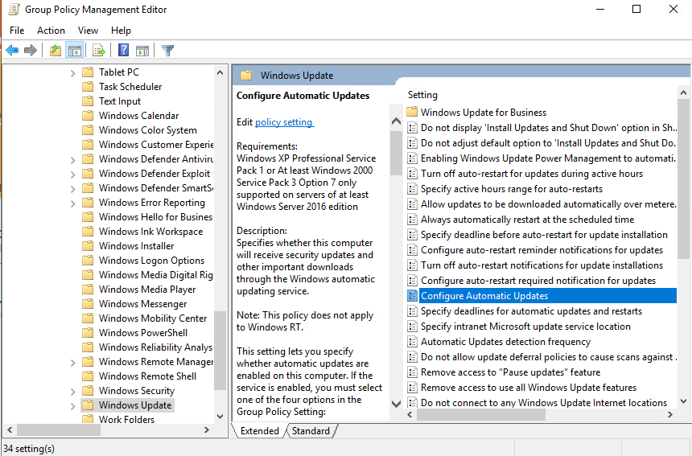

1. Find Configure Automatic Updates in Setting, double click
   * Set to auto download and schedule install
   * Set schedule to every day at 7:00PM every week
   * Click OK to save
   * Close Group Policy Management console.
2. Open command prompt or PowerShell -> Command: gpupdate /force

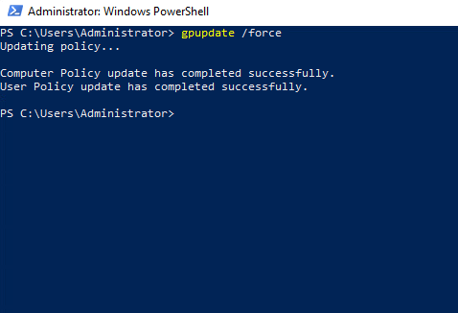

1. Run command prompt or PowerShell as Administrator
   1. Type gpresult
   2. Expand Computer Configuration section
   3. Take screenshot showing settings have applied successfully

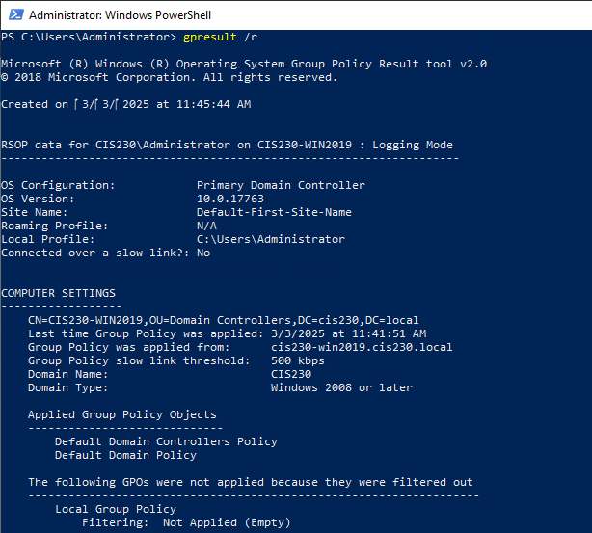

Audit Policy Remediation

1. Edit current Audit settings on system Windows Server 2019
   1. Go to Server Manager -> Tools -> Group Policy Management
   2. Expand tree two levels -> Right-click on Default Domain Policy -> Edit
   3. Expand Computer Configuration - Policies section
   4. Expand Windows Settings -> Security Settings -> Local Policies -> Audit Policy
2. Enable auditing for all listed event types – Right click, select Properties – check all boxes, click OK.

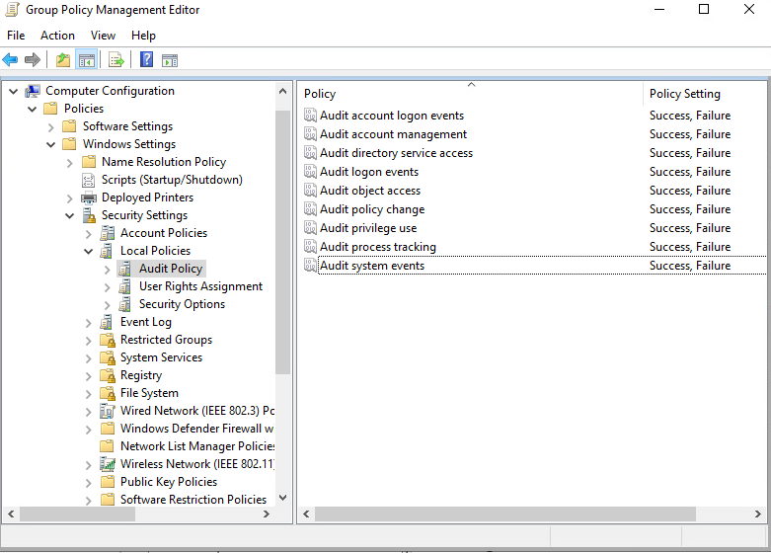

1. Close Group Policy Management Editor and Console
2. Open command prompt or PowerShell -> Command: gpupdate /force

Linux OS Execution Plan

Enable Automatic Updates in Ubuntu

1. Update Ubuntu package lists and install pending updates:
   1. Open terminal window
   2. sudo apt-get update
   3. sudo apt-get upgrade
2. Install the unattended-upgrades package with apt:
   1. sudo apt-get install unattended-upgrades

Add a screenshot here.

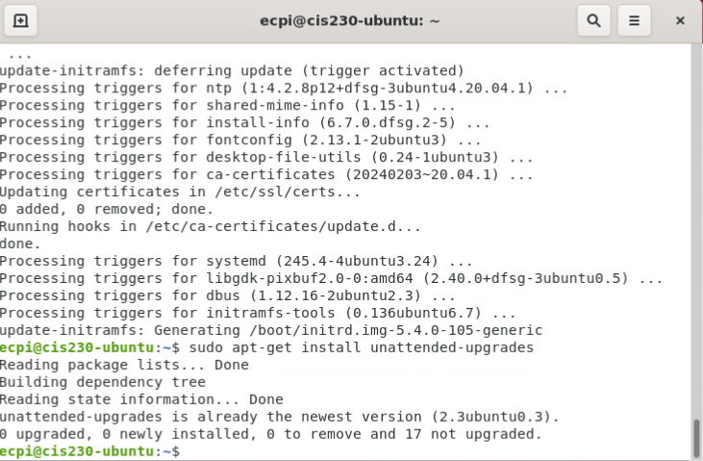

1. Enable the unattended-upgrades function
   1. sudo dpkg-reconfigure --priority=low unattended-upgrades

Add a screenshot here.

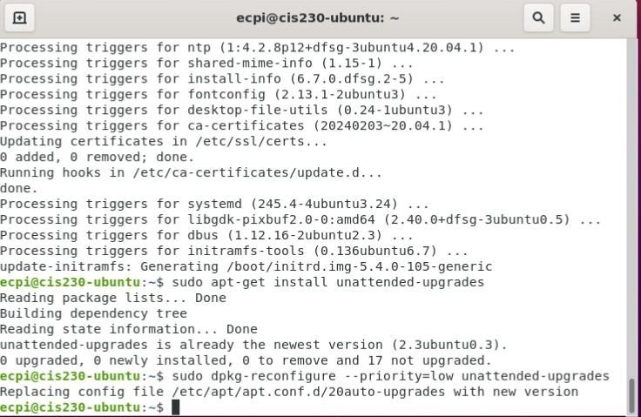

* 1. When prompted to automatically install stable updates, select YES

1. Verify unattended upgrade service is working:
   1. sudo unattended-upgrades --dry-run (2 dashes)

Add a screenshot here.

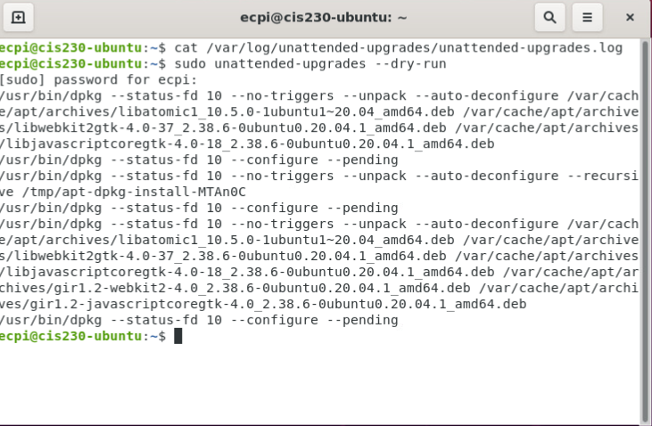tail

1. Check Unattended Upgrades Log:
   1. tail -n 100 /var/log/unattended-upgrades/unattended-upgrades.log

Add a screenshot here.

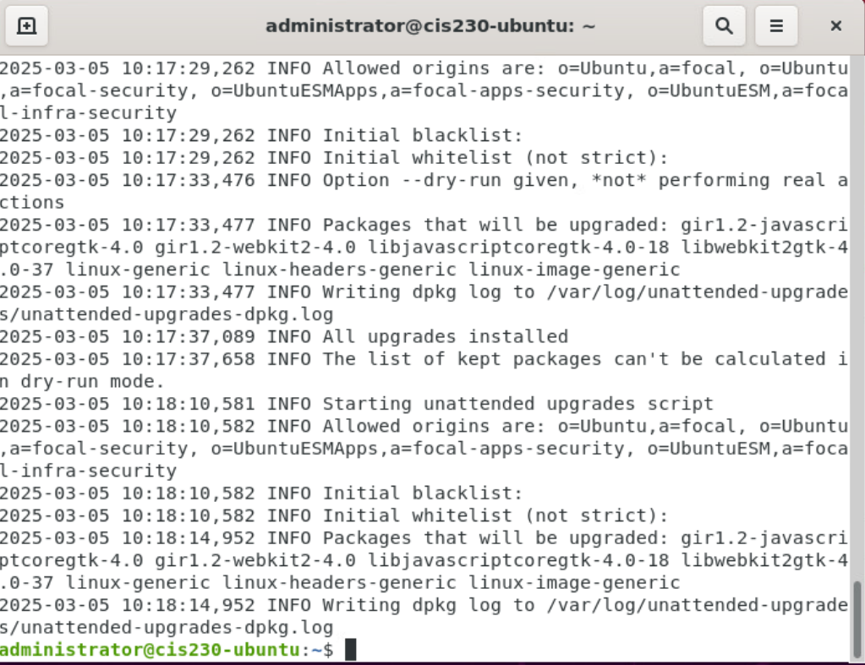

Enable and configure Auditd for security events

1. Install and configure auditd:
   1. sudo apt install auditd audispd-plugins
   2. sudo systemctl -now enable --auditd (2 dashes)
2. Set the parameter on your bootloader to enable during bootup
   1. sudo nano /etc/default/grub
      1. Find the GRUB_CMDLINE_LINUX=”“command line
      2. Change value to: GRUB_CMDLINE_LINUX=”audit=1″
      3. Save and close Nano - Ctrl o, Ctrl x
   2. sudo update-grub

Add a screenshot here.

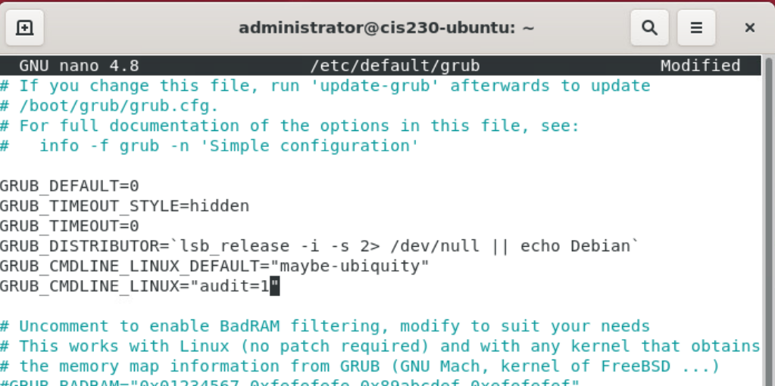

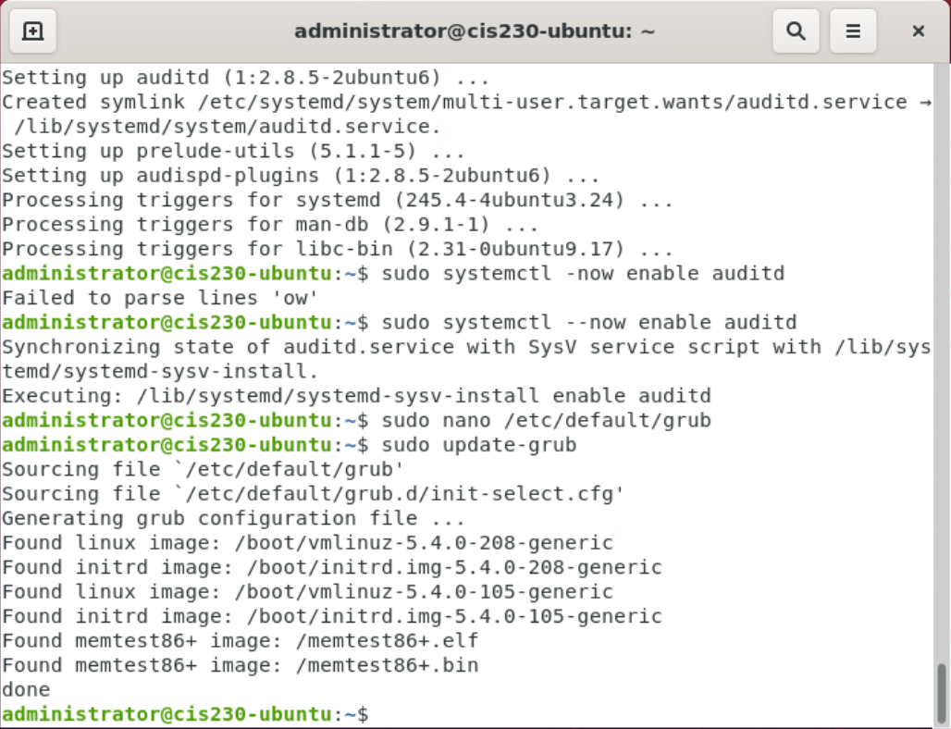

Windows Post-Execution and deliverables

1. Log on to Server 2019 as administrator
2. Execute steps from Execution Plan
3. Paste screenshots for steps in the Plan section, as appropriate
4. Log onto Window 10 client as a domain admin
5. Run command prompt or PowerShell as Administrator
   1. Type rsop.msc
   2. Expand Computer Configuration section
   3. Take screenshot showing settings have applied successfully

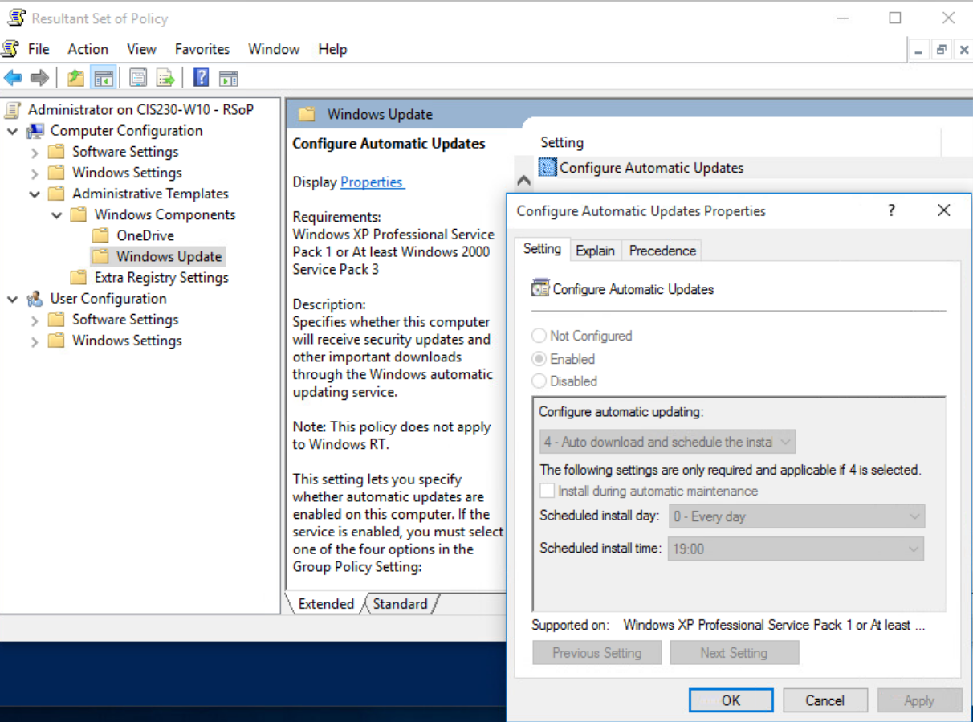

Linux Post-Execution and deliverables

1. Log on to Ubuntu
2. Execute steps from the Execution Plan
3. Paste Screenshots of all configuration changes made through the CLI



1. Screenshot of log entries
   1. tail -n 100 /var/log/unattended-upgrades/unattended-upgrades.log
   2. tail -n 100 /var/log/audit/audit.log

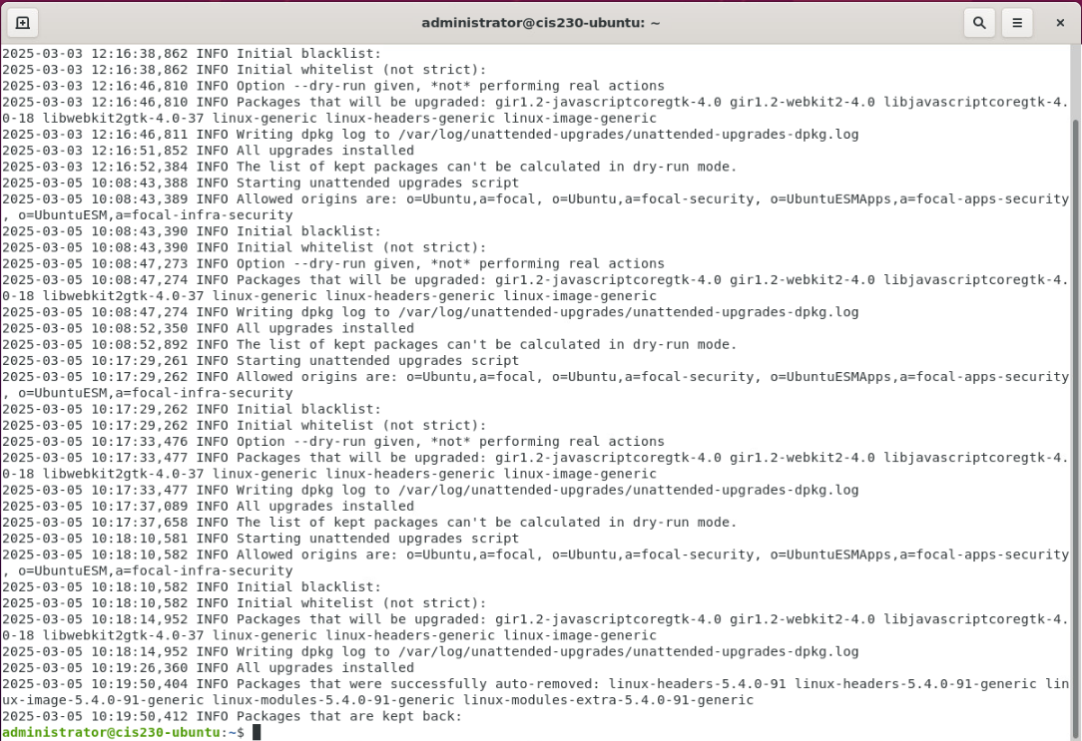

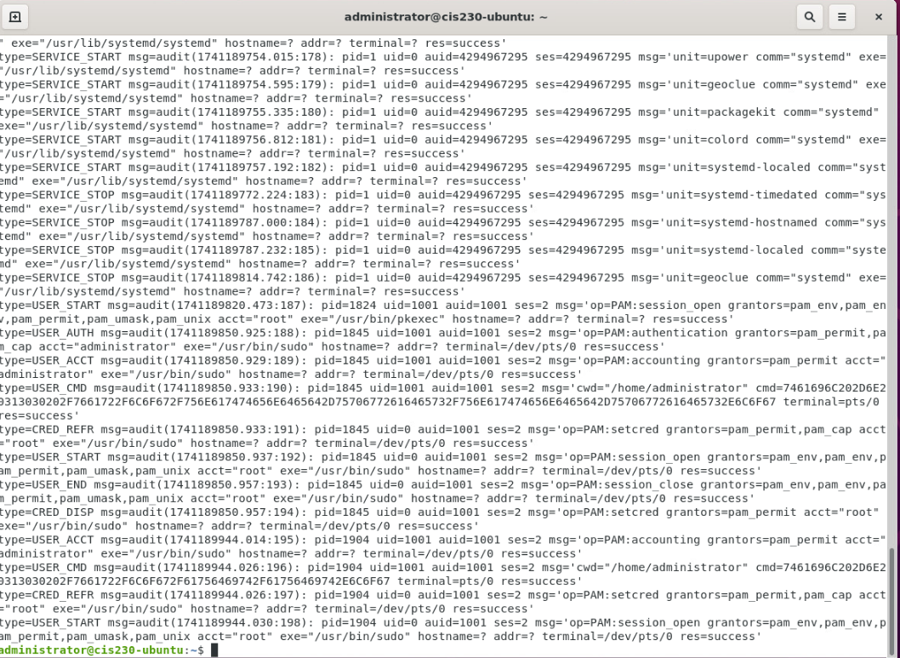

Follow-up

1. Update documentation for stakeholders by completing the following.

Progress Summary

*Update your project implementation plan here with a summary of results and related audit findings that were remediated in this assignment.* Use these system code abbreviations: LR – Linux Risk, WR – Windows Risk, FR – Firewall Risk.

Testing Procedures

* Notify Validation Group environment is ready for testing. (Here, this means submitting this document)

Back-out plan – update weekly

Windows System:

1. Revert settings to original values
2. Run a gpupdate /force

Linux System:

1. Remove automatic update
   1. sudo apt remove unattended-upgrades
2. Remove auditd
   1. sudo apt remove auditd audispd-plugins

Project Notes

Make sure you specify the systems that you are working on configuring as part of the change management process.

Server Info:

(Virtual) Server Name: CIS230-UBUNTU

OS: Ubuntu 9.4.0-1ubuntu1~20.04.2

IP Address: 172.16.30.30

Server Specs:

VM

CPU: Intel ® Xeon ® CPU E5-2640 v4 @ 240GHz

RAM: 1.9 GiB

STORAGE: 42.9 GB

NETWORK:

2 vCPU, 2GB RAM

(Virtual) Server Name: CIS230-WIN2019

OS: Windows Server 2019 Standard, 10.0.17763 Build 177763

IP Address: 172.16.10.10

Server Specs:

VM

CPU: Intel® Xeon ® CPU E5-2640 v4 @ 2.40GHz, 2397 Mhz, 2 Core(s), 2 Logical Processor(s)

RAM: 4.00 GB

STORAGE: 60 GB

NETWORK: Intel® 82574L Gigabit Network Connection

2 vCPU, 2GB RAM

(Virtual) Server Name: CIS230-WIN10

OS: Windows 10 Education, 10.0.10240 Build 10240

IP Address: 172.16.20.20

Server Specs:

VM

CPU: Intel® Xeon® CPU E5-2640 v4 @ 2.40GHz, 2397 Mhz, 1 Core(s), 1 Logical Processor(s)

RAM: 2.00 GB

STORAGE: 40.00 GB

NETWORK: Intel® 82574L Gigabit Network Connection

2 vCPU, 2GB RAM

Project Scope

*WEEK 2 Vulnerabilities to Remediate*

Windows Server - To ensure proper security measures, it is necessary to configure the network shares in a way that grants access only to the appropriate departments. The recommended configurations are as follows:

1. No access should be given to HR department.
2. Access to IT department should be granted only to their respective group.
3. Users in all departments should be granted read-only access to COMMON, except for HR which should have the ability to create, edit, and delete files.

Demo: Disable logon name showing on lock and login prompt.

Linux - To improve the security of the network shares, it is necessary to configure the appropriate groups and Samba configuration files. Specifically, the following steps should be taken:

1. Only the appropriate department groups should be granted full access, with no access given to the HR department.
2. The IT department should only be accessible from its respective group.
3. The COMMON network share should be set to read-only access for all users
   1. HR department should have permission to create, edit, and delete files.
4. The root account should be disabled for SSH access to improve security.

*Demo:* Add users to appropriate groups for shares.

Pfsense - Configure firewall rule to limit firewall admin web gui access only from Windows server,

1. ☐Create new administrative account {studentid-ADMIN}
2. ☐Login and change password for admin and
3. ☐Set account properties to disable login.

*Demo:* change default web gui port to TCP port above 1024.

Project Lead  
Your FirstName LastName and ECPI User ID

Technical Stakeholders

Your Supervisor (Instructor)

Primary Business Users

Thomas Evans - IT Department

Janet Adams - Human Resources

Mary Wilder - Customer Service

Project Summary

To achieve compliance with the items discovered in the voluntary security audit, several changes are proposed to address the issues listed in the project scope. The requirements for the necessary changes have been defined and low-level details of the specific changes are listed including validation. Risk has been assessed for contingency and backout plan is defined to respond in the event of an impact.

Preparation

1. Create project remediation plan per system
   1. Identify pre and post execution procedures (specific changes to be made and method for validation, i.e., commands or screenshots)
2. *Notify Stakeholders (Peer review of changes) (Not required, for informational purposes.)
3. *Schedule project in scheduled maintenance calendar (Not required, for informational purposes.)
4. Capture screenshot of current configuration and environment (i.e, make sure you’re logged into the right system)
5. Apply changes (commands or screenshots)
6. Document applied settings (commands or screenshots)
7. Notify Validation Group environment is ready for testing. (Not required for informational purposes.)
8. Summarize remediated vulnerabilities with reference to the specific audit findings for Final Report.
9. Submit completed document in Canvas.

VCastle Systems – Usernames and passwords

1. Windows 10 UN: cis230\administrator PW: Password1 172.16.10.10
2. Ubuntu UN: ecpi PW: Password1 172.16.20.20
3. Server 2019 UN: cis230\administrator PW: Password1 172.16.30.30
4. pfSense UN: admin PW: pfsense 172.16.100.1

Windows OS Execution Plan

Don’t Display Last Login Name

1. Edit current Windows Updates settings on system Windows Server 2019
   * Go to Server Manager --> Tools --> Group Policy Management
   * Expand tree two levels --> Right-click on Default Domain Policy --> Edit
   * Expand Computer Configuration section -> Windows Settings
   * Security Settings --> Local Policies --> Security Options
   * Locate and enable Interactive Logon: Don’t display last signed-in – Double click to open - Select Enabled – click ok
   * Locate and enable Interactive Logon: Display user information when the session is locked --> check Define this policy setting --> select Do not display user information from dropdown – click OK
   * Close all dialog boxes
2. Open command prompt or PowerShell --> Command: gpupdate /force
3. Take a screenshot showing this setting have applied successfully.

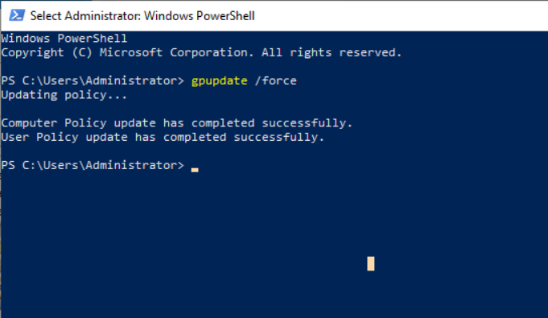

Correct Network Shares Configuration ( PowellShell)

1. List steps to verify C:\Shares and associated subfolders are correctly shared

* Go to Computer Management > System Tools > Shared Folders > Shares

Provide before and after output screenshots (Computer Management Shares)

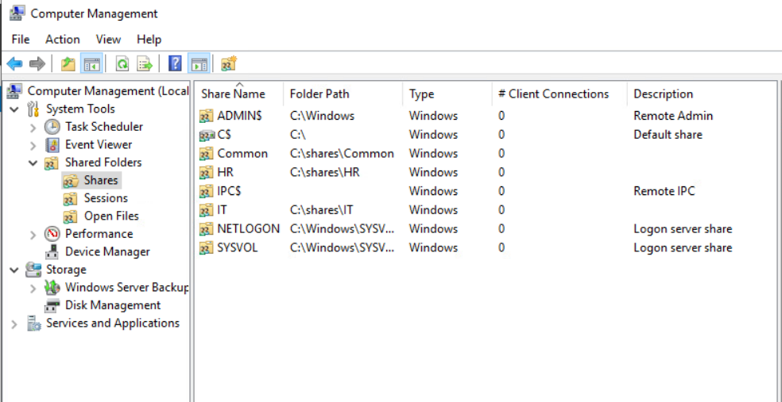

Linux OS Execution Plan

Correct network shares group access

1. Add users to groups:
   1. sudo usermod -a -G common,it tevans
   2. sudo usermod -a -G common,hr jadams
   3. sudo usermod -a -G common mwilder
2. Verify group membership
   1. cat /etc/group
   2.  Provide a screenshot

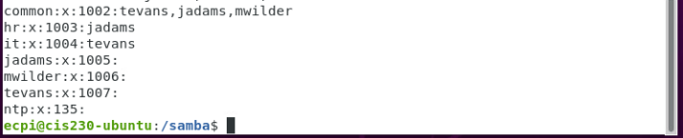

Update Samba shares configuration file with updated groups

1. Location of the Samba configuration file is /etc/samba/smb.conf
2. Use Nano to Edit sections: - refer to the Linux Vulnerabilities in Project Scope above.
   1. Set updated value for COMMON
   2. Set updated value for IT
   3. Set updated value for HR
3. Provide screenshots (before and after)

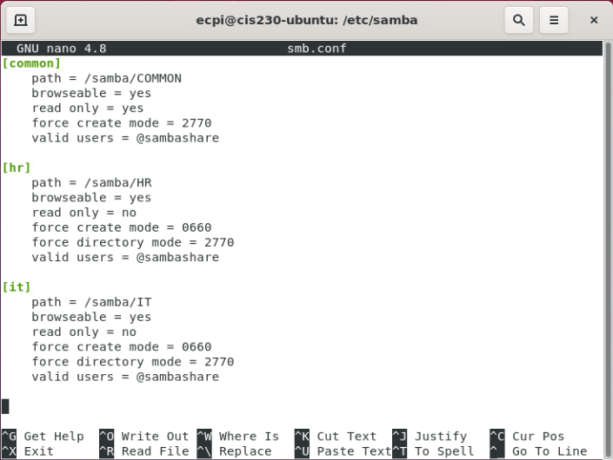

1. Restart samba services
   1. List the commands

Sudo smbd restart

1. Disable root account use over SSH
   1. List the command

Sudo nano /etc/ssh/sshd_config

Change PermitRootLogin to No

1. Provide screenshots (before and after)

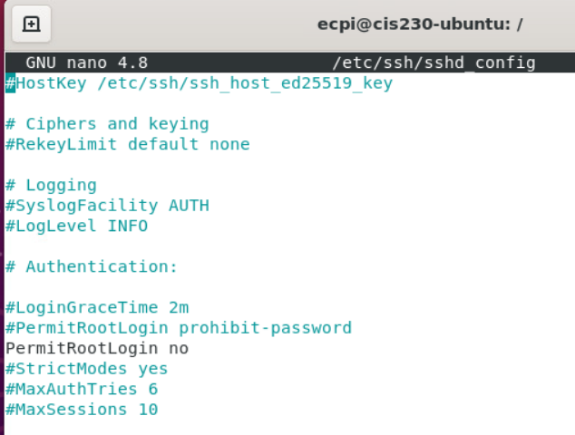

Pfsense Firewall Execution Plan

Change default admin portal TCP port

1. System --> Advanced --> TCP *number* (use port greater than 1024)
2. Provide a screenshot

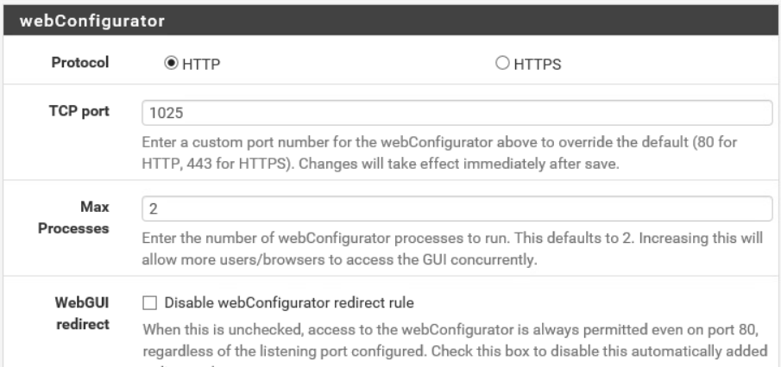

Configure web access to Pfsense GUI to allow only from Windows Server (Note: must be done in a specific order, research vendor documentation)

1. List steps
2. Log into the pfSense Web GUI
3. Open a web browser and access the pfSense GUI via: https://<pfSense-IP>
4. Login with your admin credentials.
5. Go to Firewall Rules
6. Navigate to Firewall > Rules.
7. Click on LAN (or the interface you want to control access from).
8. Create a New Rule to Allow Windows Server
9. Click Add (⬆ to insert rule at the top).
10. Action: Pass
11. Interface: LAN
12. Protocol: TCP
13. Source: Single host or alias, then enter the Windows Server’s IP
14. Destination: This firewall (self)
15. Destination Port: HTTPS (443) or HTTP (if enabled, 80)
16. Description: “Allow Windows Server to access pfSense GUI”
17. Click Save, then Apply Changes.
18. Create a Blocking Rule
19. Click Add (⬇ to insert below the allow rule).
20. Action: Block
21. Interface: LAN
22. Protocol: TCP
23. Source: Any
24. Destination: This firewall (self)
25. Destination Port: HTTPS (443) or HTTP (if enabled, 80)
26. Description: “Block all other access to pfSense GUI”
27. Click Save, then Apply Changes.
28. Ensure Rule Order
29. The allow rule for the Windows Server must be above the block rule.
30. If necessary, drag and reorder the rules.

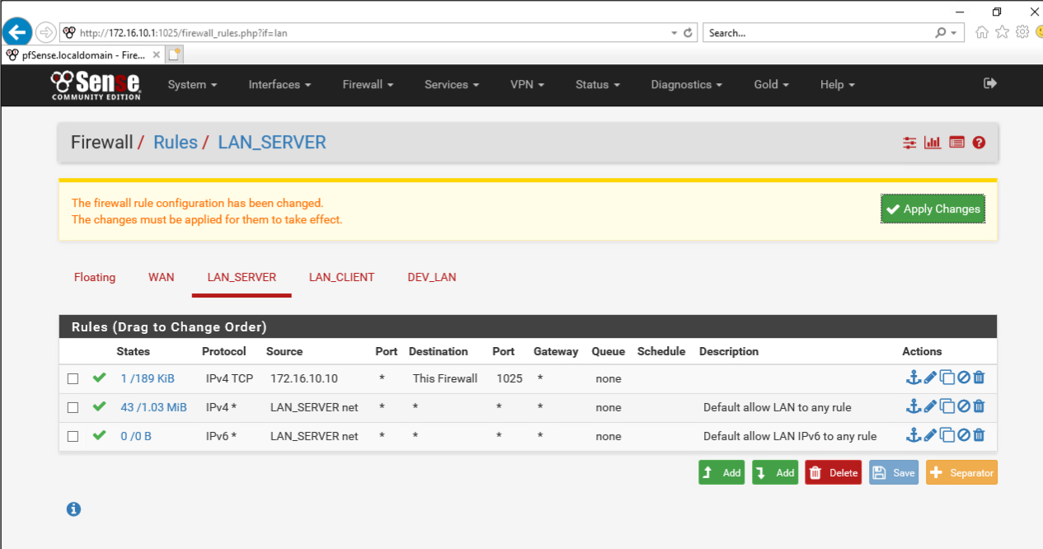

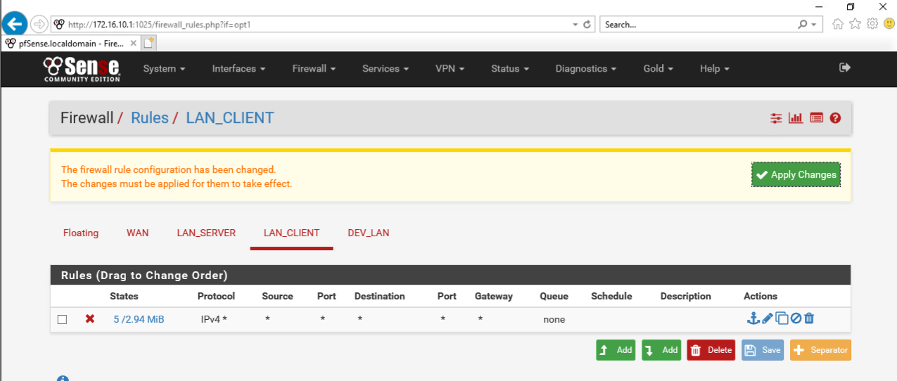

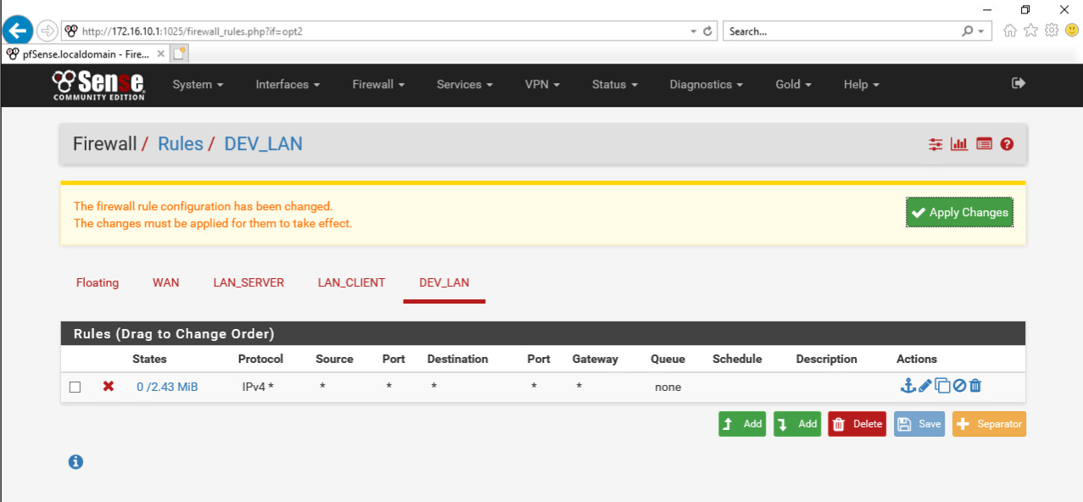

Create new administrative account and then login to change default admin account password and disable login

1. List steps

Add > Username: johan5257 > Password: Password1 > John An

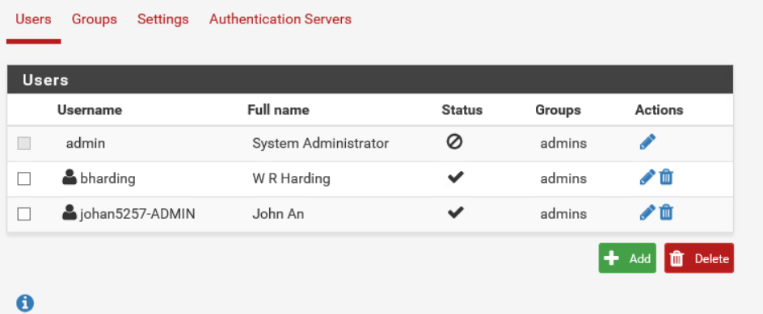

Windows Post-Execution and deliverables

1. Log onto Window 10 client as a domain admin
2. Run command prompt or PowerShell as Administrator
   1. Type gpresult /R
   2. Expand Computer Configuration section
   3. Take screenshot showing settings have applied successfully
3. Lock screen and take screenshot

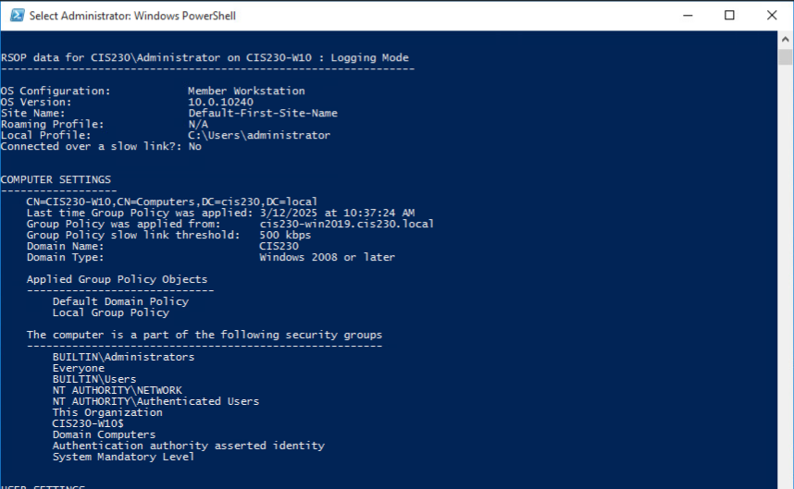

Linux Post-Execution and deliverables

1. Screenshots of any configuration changes made through the CLI not captured above
2. Screenshot showing group membership changes
   1. cat /etc/groups

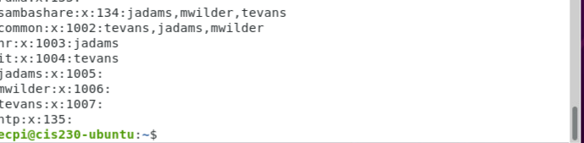

1. Screenshots of samba configuration change:
   1. cat /etc/samba/smb.conf

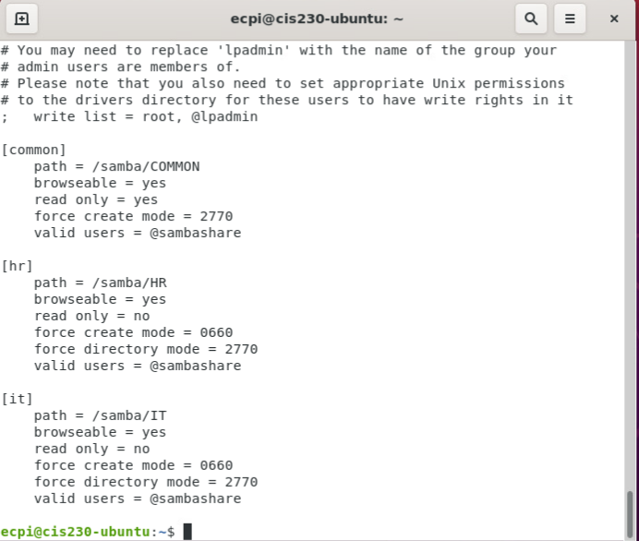

Pfsense Firewall Post-Execution and deliverables

1. Screenshot of configuration changes
   1. Screenshot showing access to admin portal with updated TCP port

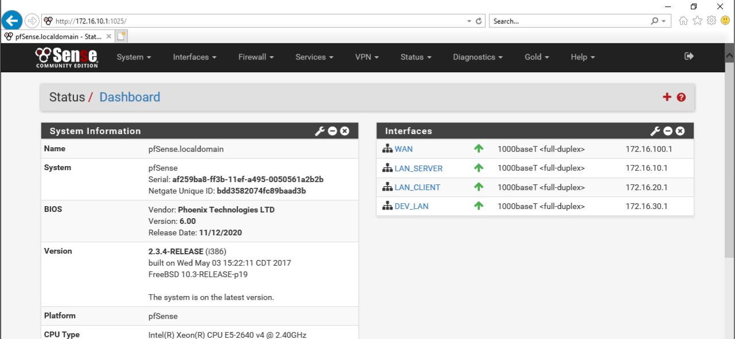

* 1. Screenshots of changes to GUI access change: System --> *Advanced, and the Firewall rules*







* 1. Screenshots showing new administrative account and disabled default admin

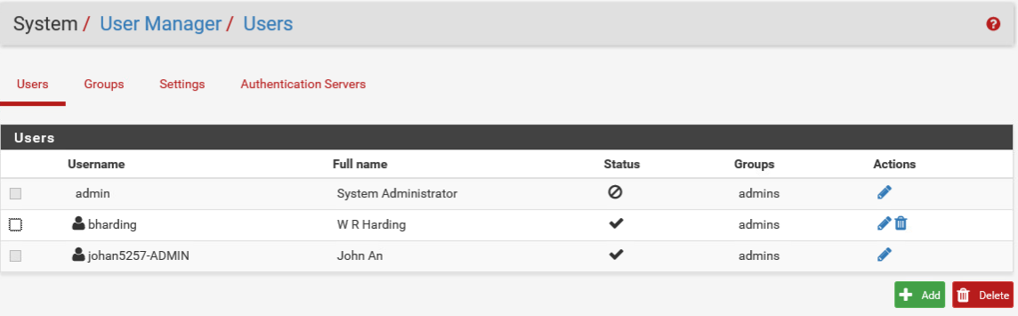

Follow-up

* Update documentation for stakeholders

Progress Summary

1. Update project remediation plan with a summary of results and related audit findings that were remediated here:

The following Security Assessment Findings were remediated:

Windows

* No access should be given to HR department.
* Access to IT department should be granted only to their respective group.
* Users in all departments should be granted read-only access to COMMON, except for HR which should have the ability to create, edit, and delete files.

Linux

* Only the appropriate department groups should be granted full access, with no access given to the HR department.
* The IT department should only be accessible from its respective group.
* The COMMON network share should be set to read-only access for all users
* HR department should have permission to create, edit, and delete files.
* The root account should be disabled for SSH access to improve security.

Firewall

* Create new administrative account {studentid-ADMIN}
* Login and change password for admin and
* Set account properties to disable login.

1. System codes: LR – Linux Risk, WR – Windows Risk, FR – Firewall Risk
2. Submit your document in Canvas.

Testing Procedures

* Notify Validation Group environment is ready for testing.

Back out plan - List steps, DO NOT Execute

Windows System:

1. Revert settings to original values
2. Run a gpupdate /force

Linux System:

1. Revert changes for groups
   1. Add users to original groups (add commands below)(Look up)
      1. ProvideCommand 1:

sudo usermod -a -G <group> <username>

* 1. Remove users from newly assigned groups (add commands below)
     1. Provide Command 1:

sudo gpasswd -d tevans common

sudo gpasswd -d tevans it  
sudo gpasswd -d jadams common

sudo gpasswd -d jadams hr  
sudo gpasswd -d mwilder common

1. Revert samba configuration change
   1. Set value for allowed users back to sambashares
      1. Edit /etc/samba/smb.conf file
   2. Save config and restart services
      1. sudo systemctl restart smbd
      2. sudo systemctl restart nmbd
      3. sudo service smbd status

Project notes   
Make sure you specify the systems that you are working on configuring as part of the change management process.

Server Info:

(Virtual) Server Name: CIS230-UBUNTU

OS: Ubuntu 9.4.0-1ubuntu1~20.04.2

IP Address: 172.16.30.30

Server Specs:

VM

CPU: Intel ® Xeon ® CPU E5-2640 v4 @ 240GHz

RAM: 1.9 GiB

STORAGE: 42.9 GB

NETWORK:

2 vCPU, 2GB RAM

(Virtual) Server Name: CIS230-WIN2019

OS: Windows Server 2019 Standard, 10.0.17763 Build 177763

IP Address: 172.16.10.10

Server Specs:

VM

CPU: Intel® Xeon ® CPU E5-2640 v4 @ 2.40GHz, 2397 Mhz, 2 Core(s), 2 Logical Processor(s)

RAM: 4.00 GB

STORAGE: 60 GB

NETWORK: Intel® 82574L Gigabit Network Connection

2 vCPU, 2GB RAM

(Virtual) Server Name: CIS230-WIN10

OS: Windows 10 Education, 10.0.10240 Build 10240

IP Address: 172.16.20.20

Server Specs:

VM

CPU: Intel® Xeon® CPU E5-2640 v4 @ 2.40GHz, 2397 Mhz, 1 Core(s), 1 Logical Processor(s)

RAM: 2.00 GB

STORAGE: 40.00 GB

NETWORK: Intel® 82574L Gigabit Network Connection

2 vCPU, 2GB RAM

Project Scope

*WEEK 3 Vulnerabilities to Remediate*

Windows Server - (Default Domain Policy) Enable Windows Firewall, allow ICMP from internal segments, enable DEP (Data Execution Prevention) policies (Default Domain Policy). Same on (Domain Controllers) GPO but block policy inheritance and add allow ssh from Linux to the server. Enable DEP policies (Default Domain Policy)

*Demo:* Enable DEP policies

Linux - Enable ufw firewall and allow only NTP from internal segments, allow SSH from Win server and client segments, allow syslog from Pfsense for firewall.

*Demo:* Allow syslog from Pfsense for firewall

Pfsense - (Firewall allows all traffic) Match the firewall rules configured for Windows and Linux and then research Active Directory required ports and set up firewall rules that allow both the Windows 10 client and Linux machine to access domain resources.

*Demo:* Create a firewall rule

Project Lead  
John An, johan5257

Technical Stakeholders

William Harding

Primary Business Users

Thomas Evans - IT Department

Janet Adams - Human Resources

Mary Wilder - Customer Service

Project Summary

To achieve compliance with the items discovered in the voluntary security audit, several changes are proposed to address the issues listed in the project scope. The requirements for the necessary changes have been defined and low-level details of the specific changes are listed including validation. Risk has been assessed for contingency and backout plan is defined to respond in the event of an impact.

Preparation

1. Create project implementation plan per system
   1. Identify pre and post execution procedures (specific changes to be made and method for validation, i.e., commands or screenshots)
2. *Notify Stakeholders (Peer review of changes) (Not required, for informational purposes.)
3. *Schedule project in scheduled maintenance calendar (Not required, for informational purposes.)
4. Capture screenshot of current configuration and environment (i.e, make sure you’re logged into the right system)
5. Apply changes (commands or screenshots)
6. Document applied settings (commands or screenshots)
7. Notify Validation Group environment is ready for testing. (Not required for informational purposes.)
8. Summarize scope of remediated vulnerabilities with reference to the specific audit findings for Final Report.
9. Submit completed document in Canvas.

VCastle Systems – Usernames and passwords

1. Windows 10 UN: cis230\administrator PW: Password1 172.16.10.10
2. Ubuntu UN: ecpi PW: Password1 172.16.20.20
3. Server 2019 UN: cis230\administrator PW: Password1 172.16.30.30
4. pfSense UN: admin PW: pfsense 172.16.100.1

Windows OS Execution Plan

Enable DEP policies for domain

1. Edit current Windows Updates settings on system Windows Server 2019
   * Go to Server Manager --> Tools --> Group Policy Management
   * Expand tree --> Right-click on Default Domain Policy --> Edit
   * Expand Computer Configuration section
   * Policies --> Windows settings --> Scripts (startup / shutdown)
     1. Add a command (double-click) startup script, browse, and select: "powershell set-execution policy unrestricted.ps1"
     2. (Info only)Script has the following:

powershell.exe Set-ExecutionPolicy unrestricted

########

bcdedit /set nx AlwaysOn

########

1. Open command prompt or PowerShell --> Command: gpupdate /force

(Default Domain Policy) Enable Windows Firewall and allow ICMP from internal networks

1. Enable Windows Firewall.

Tools > Windows Defender Firewall with Advanced Security

1. Add firewall rule to allow ICMP from internal segments.

Tools > Windows Defender Firewall with Advanced Security > Inbound > File and Printer Sharing (Echo Request – ICMPv4-In)

1. Please provide the group policy editor screenshot

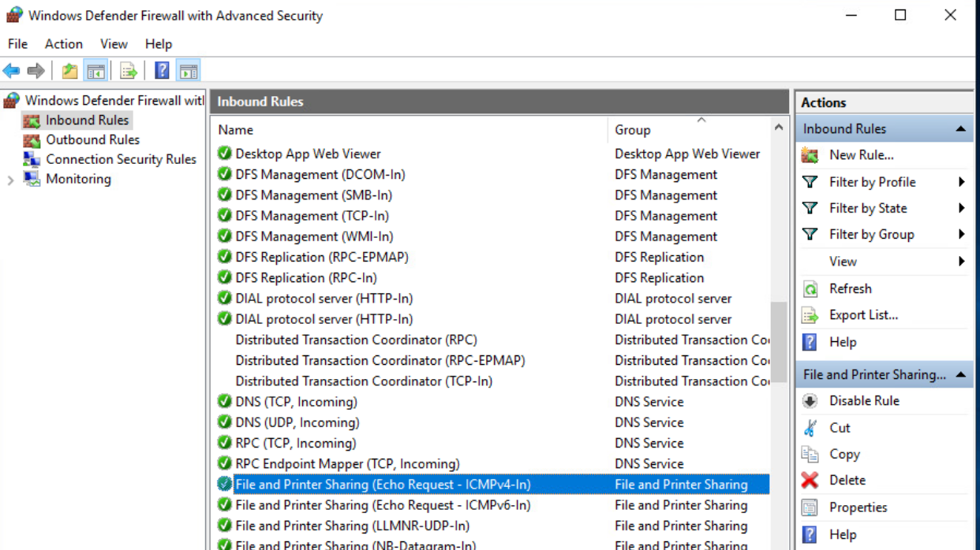

(Default Domain Controllers Policy) Edit GPO to block policy inheritance, enable firewall, and add allow ping/ssh from Linux to the server

1. Edit Domain Controllers GPO and disable inheritance –

Group Policy Management > Forest > Domain Controllers > right click > Block Inheritance

Provide the result screenshots

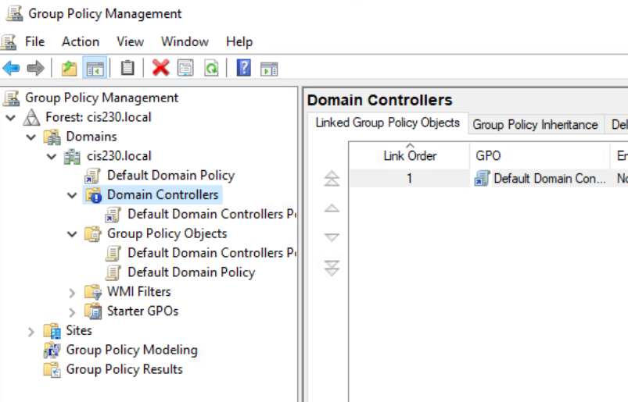

1. Enable DEP policy
   1. List all steps (will be same as for Default Domain Policy)

Edit current Windows Updates settings on system Windows Server 2019

* + Go to Server Manager --> Tools --> Group Policy Management
  + Expand tree --> Right-click on Default Domain Policy --> Edit
  + Expand Computer Configuration section
  + Policies --> Windows settings --> Scripts (startup / shutdown)
    1. Add a command (double-click) startup script, browse, and select: "powershell set-execution policy unrestricted.ps1"
    2. (Info only)Script has the following:

powershell.exe Set-ExecutionPolicy unrestricted

########

bcdedit /set nx AlwaysOn

1. Enable Windows firewall settings
   1. List all steps

Default Domain Controllers Policy > Policies > Computer Configuration > Policies > Windows Setting > Security Setting > Windows Defender Firewall with Advanced Security

1. Add firewall rules to allow icmp and ssh from Linux to Windows Server
   1. List all steps

Inbound rules > New Rules > Custom > Next > Protocol Type: UDP, Local port: 80, Remote port: 22 > Local IP: 172.16.10.1, Remote IP: 172.16.30.1 > Next > Uncheck Public > Name the rule.

Linux OS Execution Plan

Add firewall rules

1. Enable Ubuntu firewall
   1. sudo ufw enable
2. Add rule to allow syslog traffic from the Pfsense firewall:
   1. sudo ufw allow in on em1 from 172.16.10.1/24 to 172.16.30.1 proto udp port 514 (**Change IP Address to match your network**)
3. Add rule to lock down ssh access to only allow from Windows Server
   1. (add commands)
   2. 
4. Add rule to lock down ntp access to only allow from internal networks
   1. (add commands)



1. Verify firewall rules
   1. sudo ufw status numbered – add screenshot

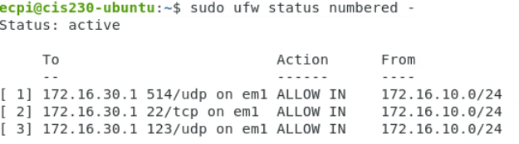

Pfsense Firewall Execution Plan

Allow ICMP between internal segments for each zone (REPEAT 3 TIMES and provide screenshot for each)

1. Firewall --> Rules --> Click on LAN1/LAN2/LAN3 --> Click on Add with down arrow
   1. Action: Pass
   2. Interface: LAN1 em1 - LAN2 em2 - LAN3 em3
   3. Protocol: ICMP
   4. ICMP Subtypes: Select Echo Reply and Echo Request
   5. Source: Network 172.16.0.0/22
   6. Destination: Interface: LAN1- 172.16.10.1 - LAN2 - 172.16.20.1 -LAN3 172.16.30.1
   7. Extra Options/Log: Check box for “Log packets that are handled by this rule”
   8. Click Save at the bottom

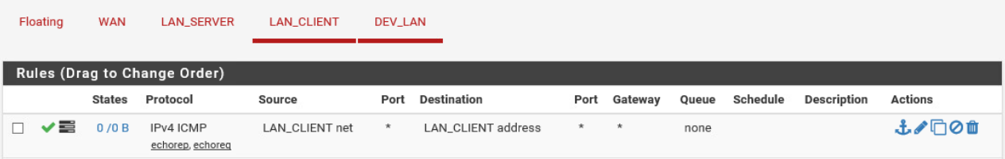

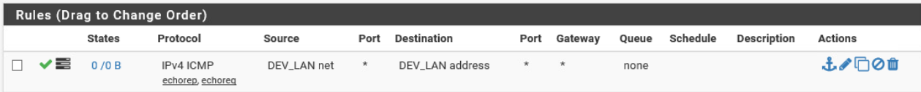

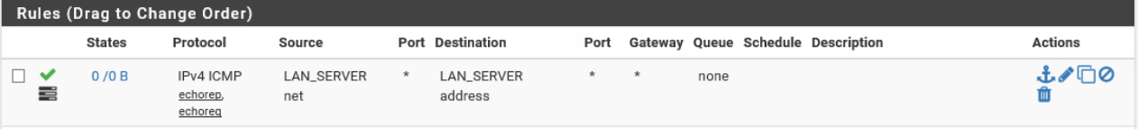

Add firewalls rules to lock down access between network segments

1. Firewall rule(s) allow traffic from Windows Server to Window 10 Client
   1. Research is required for these firewall rules
   2. Check Microsoft resources for required ports for Active Directory
2. Firewall rule allowing traffic from Windows 10 Client to Windows Server
   1. Research is required for these firewall rules
   2. Check Microsoft resources for required ports for Active Directory
3. Firewall rule(s) allowing traffic from Linux to Windows Server
   1. Permit ports required for Active Directory
   2. Permit HTTPS
4. Firewall rule(s) allowing traffic from Windows Server to Linux
   1. Permit ports required for Active Directory
   2. Permit SSH
   3. Permit NTP
5. Firewall rule allowing traffic from Windows 10 Client to Linux
   1. Permit NTP
   2. Permit ports required for Windows/Samba shares (research for answer)
6. Three screenshots: Windows Server, Windows Client, and Linux.

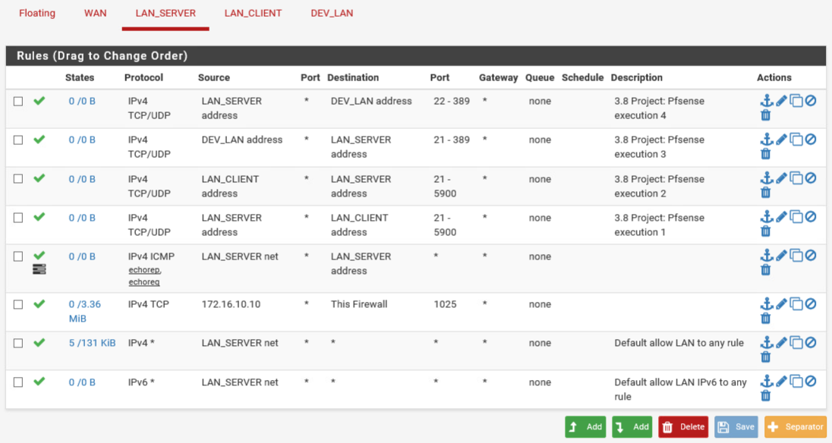

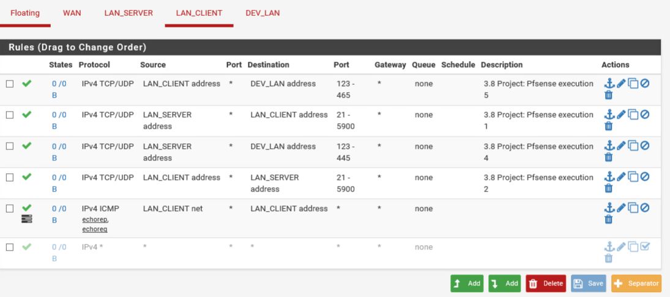

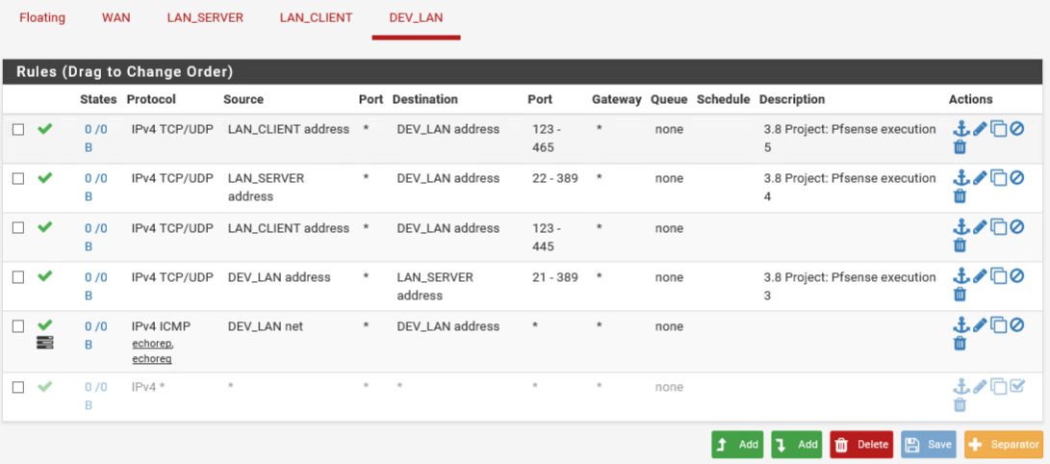

Windows Post-Execution and deliverables

1. For the server show screenshots of all group policy settings that were changed
2. Log onto Windows 10 client and run command prompt or PowerShell as Administrator
   1. Type rsop.msc
   2. Expand Computer Configuration section
   3. Take screenshots showing all settings made on the server have applied successfully

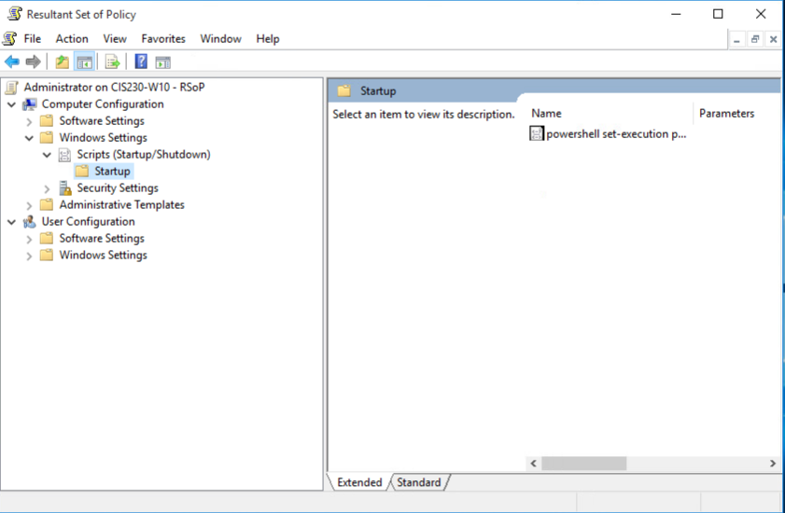

Linux Post-Execution and deliverables

1. Screenshots of all configuration changes made through the CLI
2. Screenshot showing firewall status and rules
   1. sudo ufw status numbered

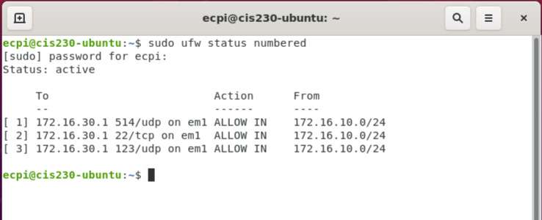

Pfsense Firewall Post-Execution and deliverables

1. Screenshots of firewall configurations

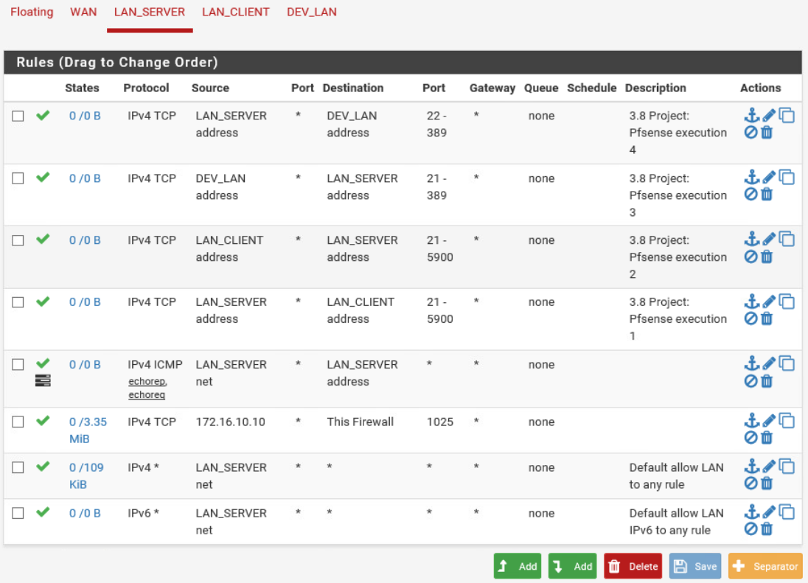

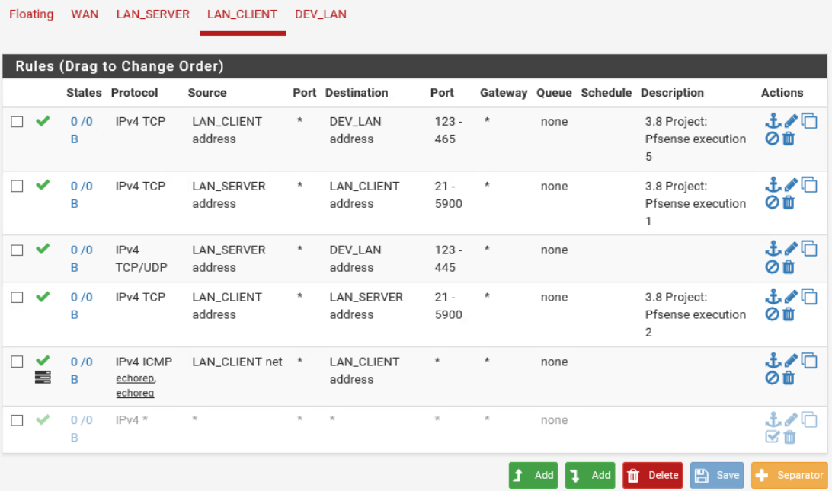



Follow-up

Update documentation for stakeholders

Progress Summary

1. Update project implementation plan with a summary of results and related audit findings that were remediated here:

The following Security Assessment Findings were remediated:

Windows Server - (Default Domain Policy) Enable Windows Firewall, allow ICMP from internal segments, enable DEP (Data Execution Prevention) policies (Default Domain Policy). Same on (Domain Controllers) GPO but block policy inheritance and add allow ssh from Linux to the server. Enable DEP policies (Default Domain Policy)

Linux - Enable ufw firewall and allow only NTP from internal segments, allow SSH from Win server and client segments, allow syslog from Pfsense for firewall.

Pfsense - (Firewall allows all traffic) Match the firewall rules configured for Windows and Linux and then research Active Directory required ports and set up firewall rules that allow both the Windows 10 client and Linux machine to access domain resources.

System codes: LR – Linux Risk, WR – Windows Risk, FR – Firewall Risk

1. Submit in Canvas

Testing Procedures

* Notify Validation Group environment is ready for testing.

Back out plan: revise each week as necessary. List steps, do not execute

Windows Server:

1. Revert Default Domain Policy and Default Domain Controllers Policy GPO settings to original values
2. Run a gpupdate /force

Linux System:

1. Disable firewall
   1. sudo ufw disable

Pfsense System:

1. Revert configuration to previous version
   1. Diagnostics --> Config History --> select restore point and click 

Project notes  
Make sure you specify the systems that you are working on configuring as part of

the change management process.

Server Info:

(Virtual) Server Name: CIS230-UBUNTU

OS: Ubuntu 9.4.0-1ubuntu1~20.04.2

IP Address: 172.16.30.30

Server Specs:

VM

CPU: Intel ® Xeon ® CPU E5-2640 v4 @ 240GHz

RAM: 1.9 GiB

STORAGE: 42.9 GB

NETWORK:

2 vCPU, 2GB RAM

(Virtual) Server Name: CIS230-WIN2019

OS: Windows Server 2019 Standard, 10.0.17763 Build 177763

IP Address: 172.16.10.10

Server Specs:

VM

CPU: Intel® Xeon ® CPU E5-2640 v4 @ 2.40GHz, 2397 Mhz, 2 Core(s), 2 Logical Processor(s)

RAM: 4.00 GB

STORAGE: 60 GB

NETWORK: Intel® 82574L Gigabit Network Connection

2 vCPU, 2GB RAM

(Virtual) Server Name: CIS230-WIN10

OS: Windows 10 Education, 10.0.10240 Build 10240

IP Address: 172.16.20.20

Server Specs:

VM

CPU: Intel® Xeon® CPU E5-2640 v4 @ 2.40GHz, 2397 Mhz, 1 Core(s), 1 Logical Processor(s)

RAM: 2.00 GB

STORAGE: 40.00 GB

NETWORK: Intel® 82574L Gigabit Network Connection

2 vCPU, 2GB RAM

Project Scope

*WEEK 4 Vulnerabilities to Remediate*

Windows Server - Missing password policies, missing account lockout policies, all users member of Domain Admins

*Demo:* Review how/where to edit GPO’s and Active Directory Users and Computers console

Linux - Disable root password, remove sudo access from non-admin users, enable and enforce secure password policies on Ubuntu local users

*Demo:* Enable and enforce secure password policies on Ubuntu local users

Pfsense - Create two groups, one with read only and one with admin privileges, create two users {studentID}-ro and studentID}-rw privileges

*Demo:* Navigate GUI sections related to requirements

Project Lead  
John An

Technical Stakeholders

Bill Harding

Primary Business Users

Thomas Evans - IT Department

Janet Adams - Human Resources

Mary Wilder - Customer Service

Project Summary

To achieve compliance with the items discovered in the voluntary security audit, several changes are proposed to address the issues listed in the project scope. The requirements for the necessary changes have been defined and low-level details of the specific changes are listed including validation. Risk has been assessed for contingency and backout plan is defined to respond in the event of an impact.

Preparation

1. Create project remediation plan per system
   1. Identify pre and post execution procedures (specific changes to be made and method for validation, i.e., commands or screenshots)
2. *Notify Stakeholders (Peer review of changes) (Not required, for informational purposes.)
3. *Schedule project in scheduled maintenance calendar (Not required, for informational purposes.)
4. Capture screenshot of current configuration and environment (i.e, make sure you’re logged into the right system)
5. Apply changes (commands or screenshots)
6. Document applied settings (commands or screenshots)
7. Notify Validation Group environment is ready for testing. (Not required for informational purposes.)
8. Summarize scope of remediated vulnerabilities with reference to the specific audit findings for Final Report.
9. Submit completed document in Canvas.

VCastle Systems – Usernames and passwords:

1. Windows 10 UN: cis230\administrator PW: Password1 172.16.10.10
2. Ubuntu UN: ecpi PW: Password1 172.16.20.20
3. Server 2019 UN: cis230\administrator PW: Password1 172.16.30.30
4. pfSense UN: admin PW: pfsense 172.16.100.1

Windows OS Execution Plan

All users member of Domain Admins

Edit and update existing Active Directory user/group configurations

Conditions:

*(Remove non IT users from IT group, Create an IT_AdminAccess group and add to Domain Admins, create separate account for IT users' administrative actions, add to new group, and remove the "IT" user group from Domain Admins)

1. **Edit Active Directory Users and Computers configuration**
   * Go to Server Manager --> Tools --> Active Directory Users and Computers
   * List remaining steps:

Create IT_AdminAccess group:

* + - Right-click Users > New > Group > Group Name: IT_AdminAccess

Add to Domain Admin:

* + - Right-click IT_AdminAccess > Properties > Members > Remove IT user

Create IT Admin user:

* + - Right-click User > Properties > New > User > First name: IT Admin, User logon name: ITAdmin, Password: Password1

Remove Domain Admin from IT group:

* + - Right-click the group IT > Properties > Member Of > Remove Domain Admins

Add John An to IT group:

* + - Right-click User > Properties > New > User > First name: John, User logon name: jan, Password: Password1

1. **Verify administrative login on Windows 10 client**
   * Log in as normal IT user account
   * Complete an admin function and take screenshots of successful action with new admin actions account for and execution (include admin prompt login)

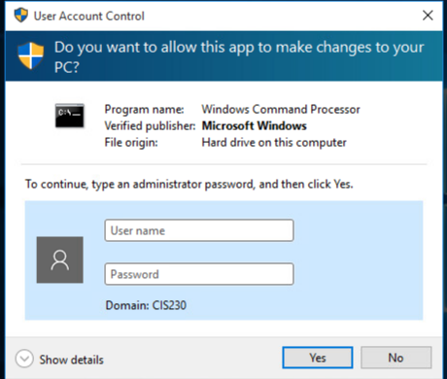

Enable and set password policies:

Password History = 24

Maximum password age = 90 days

Minimum password age = 5 days

Enable Complexity requiements

Minimum password length = 12 characters

1. List steps & provide screenshot:

Right-click Default Domain Controller Policy > Edit > Computer Configuration > Policies > Windows Settings > Security Settings > Account Policies > Password Policy

* + Enforce Password history: 24
  + Max password age: 90
  + Min password age: 5
  + Password must meet complexity requirements: Enabled
  + Min password length: 12

Enable and set account lockout policies

1. List steps & provide screenshot:

Right-click Default Domain Controller Policy > Edit > Computer Configuration > Policies > Windows Settings > Security Settings > Account Policies > Account Lockout Policy

* + Account lockout duration: 45 mins
  + Account lockout threshold: 5 invalid logon attempts
  + Reset account lockout counter after: 30 mins

Linux OS Execution Plan

Enable and enforce secure password policies

The following is also an example of how you can manually change the explicit expiration date (-E) to 01/31/2030, minimum password age (-m) of 5 days, maximum password age (-M) of 90 days, inactivity period (-I) of 30 days after password expiration, and a warning time period (-W) of 14 days before password expiration:

sudo chage -E 01/31/2030 -m 5 -M 90 -I 30 -W 14 *username*

*Before:*

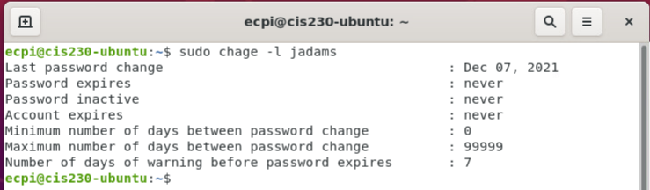

Edit user accounts with password settings and expiry

1. List steps

Terminal > sudo chage -E 01/31/2030 -m 5 -M 90 -I 30 -W 14 *jadams*

Screenshot:

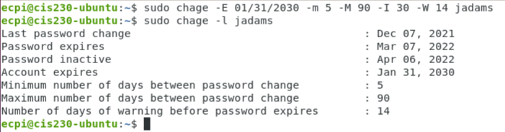

Disable root password

1. List steps

Terminal > sudo passwd -l root

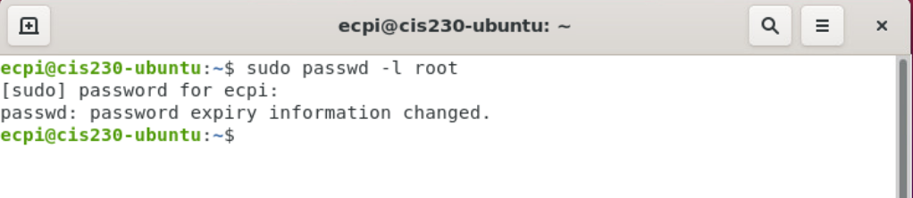

Remove sudo access from non-admin users

1. List steps

sudo deluser jadams sudo

sudo deluser mwilder sudo

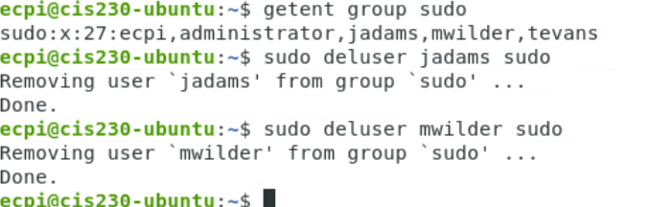

Pfsense Firewall Execution Plan

Configure access users and groups for read-only and read-write levels of administrative access

1. System --> User Manager -->
   1. Create RO and RW administrative groups
      1. RO is read only
      2. RW allows admin/write access
   2. Create two user accounts and add to respective groups
      1. studentID-ro
      2. studentID-rw
   3. Log in with RO account and confirm unable to make changes
   4. Log in with RW account and confirm changes can be made

Windows Post-Execution and deliverables:

1. Log onto Window 10 client as a domain admin
2. Run command prompt or PowerShell as Administrator
   1. Type rsop.msc
   2. Expand Computer Configuration section
   3. Take screenshot showing settings have applied successfully

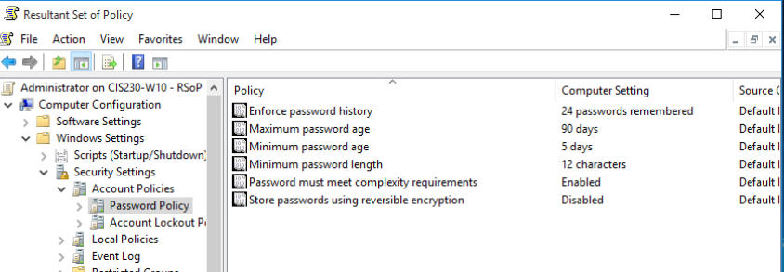

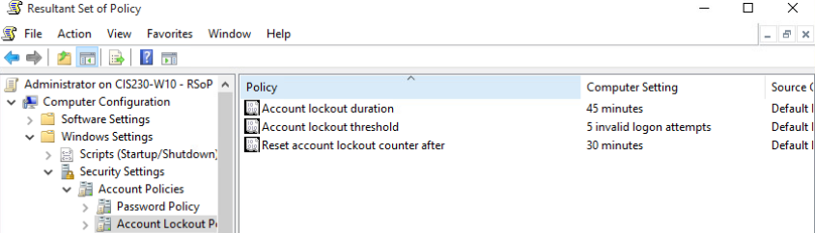

Linux Post-Execution and deliverables:

1. Screenshots of all configuration changes made through the CLI







1. Screenshot showing
   1. sudo ufw status numbered

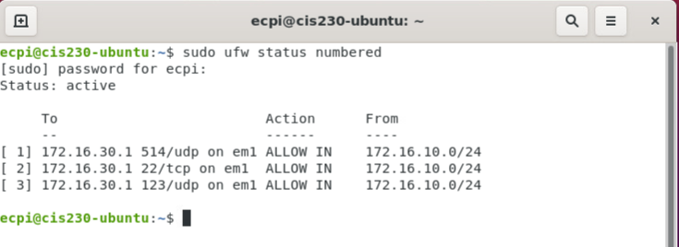

Pfsense Firewall Post-Execution and deliverables:

1. Screenshots of firewall configurations

Group creation for johan5257-ro / johan5257-rw:

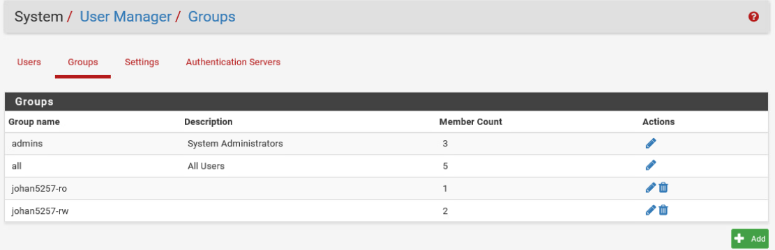

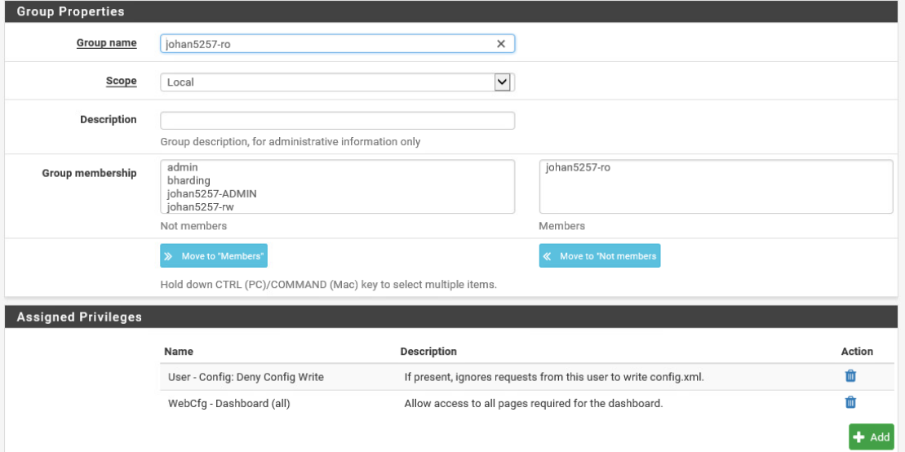

User creation for johan5257-ro / johan5257-rw:

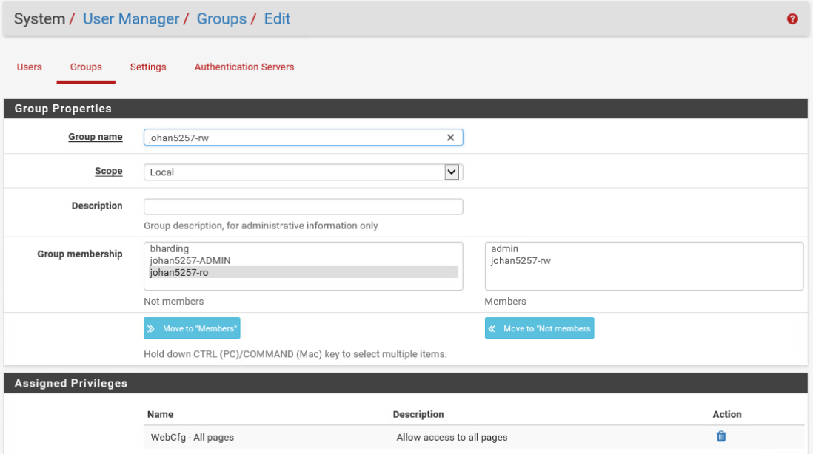

Follow-up

* Update documentation for stakeholders

Progress Summary

* + - 1. Update project remediation plan with a summary of results and related audit findings that were remediated here:

The following Security Assessment Findings were remediated:

1. Windows Server – Domain Admins Group Misconfiguration

2. Windows Server – Missing Password Policies

3. Windows Server – Missing Account Lockout Policies

4. Linux – Weak User Access Control

5. Linux – Weak Password Policies

6. pfSense Firewall – Lack of Role-Based Access Control

System codes: LR – Linux Risk, WR – Windows Risk, FR – Firewall Risk

* + - 1. Submit in Canvas

Testing Procedures

Notify Validation Group environment is ready for testing.

Back out plan: revise each week as necessary. List steps, do not execute

Windows Server:

1. Revert settings to original values
2. Run a gpupdate /force

Linux System:

1. Disable firewall
   1. sudo ufw disable

Pfsense Firewall:

1. Revert configuration to previous version
   1. Diagnostics --> Config History --> select restore point and click 

Project notes

Make sure you specify the systems that you are working on configuring as part of the change management process.

Server Info:

(Virtual) Server Name: CIS230-UBUNTU

OS: Ubuntu 9.4.0-1ubuntu1~20.04.2

IP Address: 172.16.30.30

Server Specs:

VM

CPU: Intel ® Xeon ® CPU E5-2640 v4 @ 240GHz

RAM: 1.9 GiB

STORAGE: 42.9 GB

NETWORK:

2 vCPU, 2GB RAM

(Virtual) Server Name: CIS230-WIN2019

OS: Windows Server 2019 Standard, 10.0.17763 Build 177763

IP Address: 172.16.10.10

Server Specs:

VM

CPU: Intel® Xeon ® CPU E5-2640 v4 @ 2.40GHz, 2397 Mhz, 2 Core(s), 2 Logical Processor(s)

RAM: 4.00 GB

STORAGE: 60 GB

NETWORK: Intel® 82574L Gigabit Network Connection

2 vCPU, 2GB RAM

(Virtual) Server Name: CIS230-WIN10

OS: Windows 10 Education, 10.0.10240 Build 10240

IP Address: 172.16.20.20

Server Specs:

VM

CPU: Intel® Xeon® CPU E5-2640 v4 @ 2.40GHz, 2397 Mhz, 1 Core(s), 1 Logical Processor(s)

RAM: 2.00 GB

STORAGE: 40.00 GB

NETWORK: Intel® 82574L Gigabit Network Connection

2 vCPU, 2GB RAM

Project Scope

*WEEK 5 Vulnerabilities to Remediate*

Windows Server - Add SSL to IIS website, configure public key logon to Linux server (generate ssh keys and copy over to Linux).

*Demo:* Configure CA role and certificate templates.

Linux - Configure sshd_config to allow public key authentication, create two users {studentID}-ro and studentID}-rw with passwords and generate RSA keys for each for access to the Pfsense firewall.

*Demo:* Add Windows CA certificate as a trusted Root CA.

Pfsense - Enable secured SSH access and require public key authentication, add generated SSH keys from Linux users {studentID}-ro and studentID}-rw, change to custom port 2022.

*Demo:* Navigate GUI sections related to requirements.

Project Lead  
John An

Technical Stakeholders

Bill Harding

Primary Business Users

Thomas Evans - IT Department

Janet Adams - Human Resources

Mary Wilder - Customer Service

Project Summary

To achieve compliance with the items discovered in the voluntary security audit, several changes are proposed to address the issues listed in the project scope. The requirements for the necessary changes have been defined and low-level details of the specific changes are listed including validation. Risk has been assessed for contingency and backout plan is defined to respond in the event of an impact.

Preparation

1. Create project remediation plan per system
   1. Identify pre and post execution procedures (specific changes to be made and method for validation, i.e., commands or screenshots)
2. *Notify Stakeholders (Peer review of changes) (Not required, for informational purposes.)
3. *Schedule project in scheduled maintenance calendar (Not required, for informational purposes.)
4. Capture screenshot of current configuration and environment (i.e, make sure you’re logged into the right system)
5. Apply changes (commands or screenshots)
6. Document applied settings (commands or screenshots)
7. Notify Validation Group environment is ready for testing. (Not required for informational purposes.)
8. Summarize scope of remediated vulnerabilities with reference to the specific audit findings for Final Report.
9. Submit completed document in Canvas.

VCastle Systems – Usernames and passwords:

1. Windows 10 UN: cis230\administrator PW: Password1 172.16.10.10
2. Ubuntu UN: ecpi PW: Password1 172.16.20.10
3. Server 2019 UN: cis230\administrator PW: Password1 172.16.30.10
4. pfSense UN: admin PW: pfsense 172.1.100.1

Icon Legend

You will see the following icons to indicate if the project step or activity will be done with the instructor, in your group, or independently.

 : Represents Instructor Led activities

 : Represents group activities

 : Represents individual activities

 : Represents screenshot requirement

Windows OS Execution Plan

Configure Certification Authority Role on Windows Server

1. Server Manager --> Add the Role
   1. Next on first screen
   2. Leave “Role-based or Feature-based installation” selected and click next
   3. Leave default for “Destination Server” and Click next
   4. Select
      1. Active Directory Certificate Services
      2. Certification Authority and Web Enrollment should be Selected
      3. --> on prompt click “Add Features”
      4. Click next and then next again
   5. Leave defaults and continue through to install
2. Once install is complete click on the  and then on “Configure Active Directory…”
   1. Leave default on first prompt and Click Next
   2. Check the box for Certification Authority and select Web Enrollments.
   3. Click Next through all of the remaining prompts
3. Configure web server template and issue certificate
   1. Server Manager --> Tools --> Certification Authority – Expand cis230
   2. Right-click on Certificate Templates --> select Manage (opens Certificate Template Console)
   3. Find and Right-click on Web Server --> select Duplicate Template
      1. Click on General tab
      2. Change Template display name: Web-Server-Template -->
      3. Check box for “Publish certificate in Active Directory”
      4. Click on Subject Name tab
      5. Select “Build from this Active Directory Information”
      6. Select from dropdown Subject name format: DNS name --> under Include this information in alternate subject name: check DNS name box
      7. Click on Security tab --> with Authenticated Users selected --> Permissions for Authenticated Users: check Enroll box in Allow column
      8. Close Certificate Template Console by selecting OK and you’re back at Certification Authority
   4. Issue Certificate Template
      1. Right-click on Certificate Templates -->
      2. Select New - Certificate Template to Issue (opens Enable Certificate Templates prompt) -->
      3. Select Web-Server-Template and click OK.
      4. Close dialog box.
   5. Create new certificate for Web Server
      1. Right Click on Windows start. Select Run and type mmc. Click OK(opens empty console)
      2. Click on File --> Add/Remove snap-in (opens prompt) --> select Certificates Select Add and Computer Account. Select Local computer.
      3. Click Finish and OK. (closes prompt and back at main window)
      4. Expand Certificates - Personal --> Certificates (you see one certificate and we will add a new one to use in IIS) -->
      5. Right-click All Tasks --> Request New Certificate (prompt opens).
      6. Select next.Certificate Enrollment prompt -->
      7. Click next for following two prompt --> Request Certificates -->
      8. Select and right-click on Web-Server-Template --> Certificate Properties --> Friendly name: CIS230-SSL-WEB and click ok --> click Enroll and then Finish
      9. Save Root CA Certificate to file (DO NOT EXPORT PRIVATE KEY)
      10. On PowerShell type the following command
          1. cd into where you saved the cert file: scp .\fileName [student@192.168.1.10:/home/student/](mailto:student@192.168.1.10:/home/student/)
          2. Check the filewall if cannot connect
      11. Close mmc
      12. 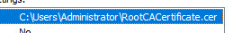
4. Enable SSL and set new certificate
   * 1. Server Manager --> Tools --> Internet Information Services -->
     2. Expand LAB-SRV-DC01 --> expand Sites -->
     3. Click on Default Web Site --> on right side under “Actions” and “Edit Site
     4. Click on “Bindings…” --> prompt opens for Site Bindings -->
     5. Click Add…--> prompt opens Add Site Binding -->
     6. Set Type to https (SSL Certificate: will now show) and select CIS230-SSL-Web and click OK -->
     7. Click Close on Site Bindings --> back on main IIS window on the right side and under “Manage Website”, click on Restart
   1. Verify SSL on Web Server
      1. Open up an Internet browser and go to [https://lab-srv-dc01-cis230-lab.local](https://lab-srv-dc01-cis230-lab.local/) (may show as cis230-win2019.cis230.local) and the little lock should show as trusted site. 

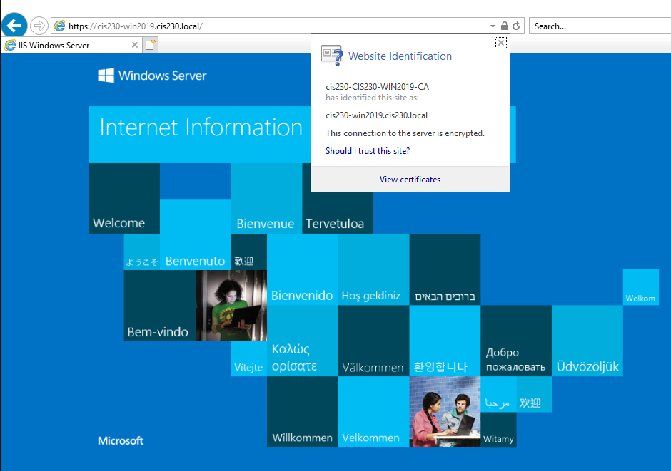

Configure RSA keys for Administrator and copy to Linux for public key logon. (Powershell)

1. ssh-keygen -t rsa
2. Accept all prompts (pay attention to where the files are saved)

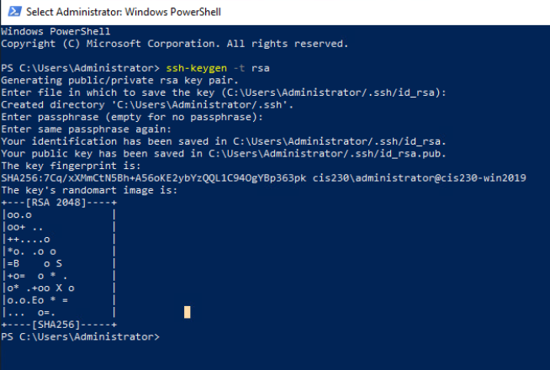

1. scp copy file from the server to the appropriate director
2. You should log in to the Linux server without password

Note:Linux part must be completed to validate public key login.

Linux OS Execution Plan

Modify /etc/hosts to Resolve Windows webpage

1. Open terminal.
2. Type: sudo vi /etc/hosts pi
3. Add the following line: 172.16.10.10 cis230-win2019.cis230.local
4. Save the changes in the text editor.
5. Verify the changes in /etc/hosts.

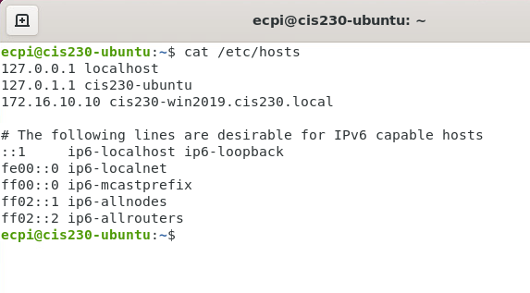

1. Verify that you can ping the address and open Firefox to see if webpage will load.

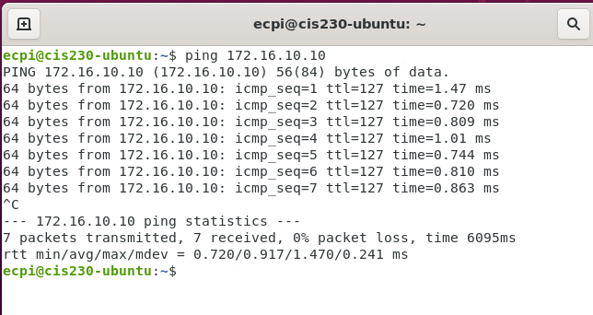

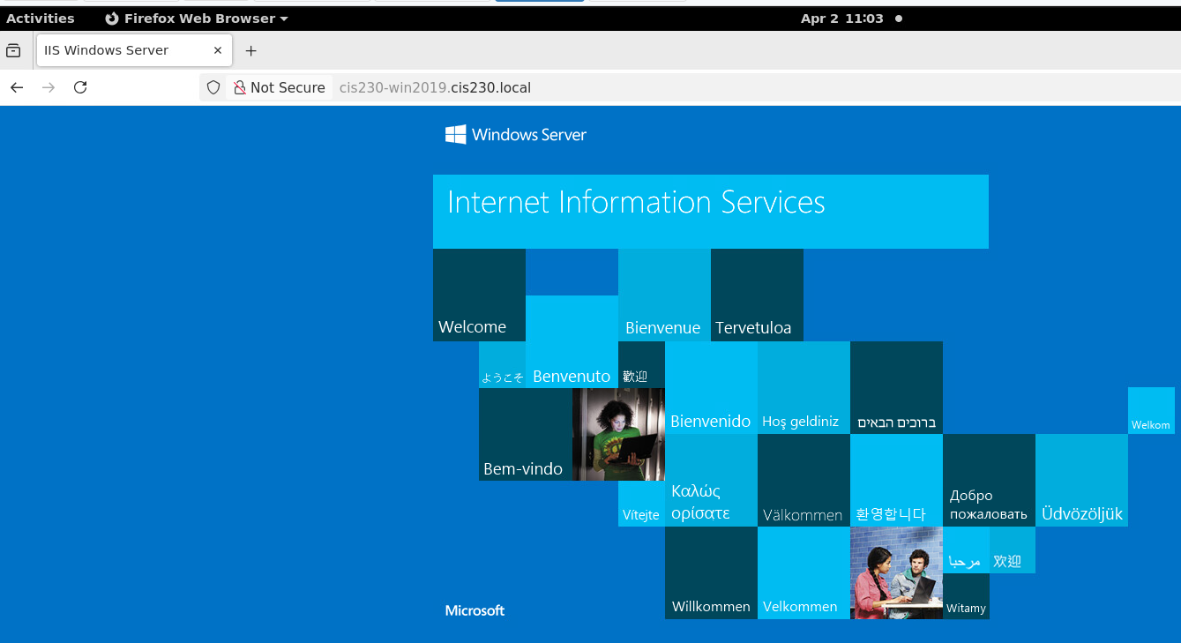

Add Windows CA certificate as a trusted Root CA

1. Copy certificate file from Windows Server to Linux
   1. sudo cp win-ca-cert.cer /usr/local/share/ca-certificates/win-ca-cert.cer
2. Update CA store
   1. sudo update-ca-certificates
3. Open Internet browser and go to the IIS website
   1. On Firefox, you will manually add the win-ca-cert.crt file to Trusted Root Certification Authority (located in Downloads)
      1. Open Firefox and go to Options:
      2. Click Privacy & Security in the left-hand menu and scroll down to Certificates.
      3. Click View Certificates... and the Certificate Manager window displays.
      4. Click Authorities and then Import
      5. Browse to locate the downloaded ca
      6. Click OK

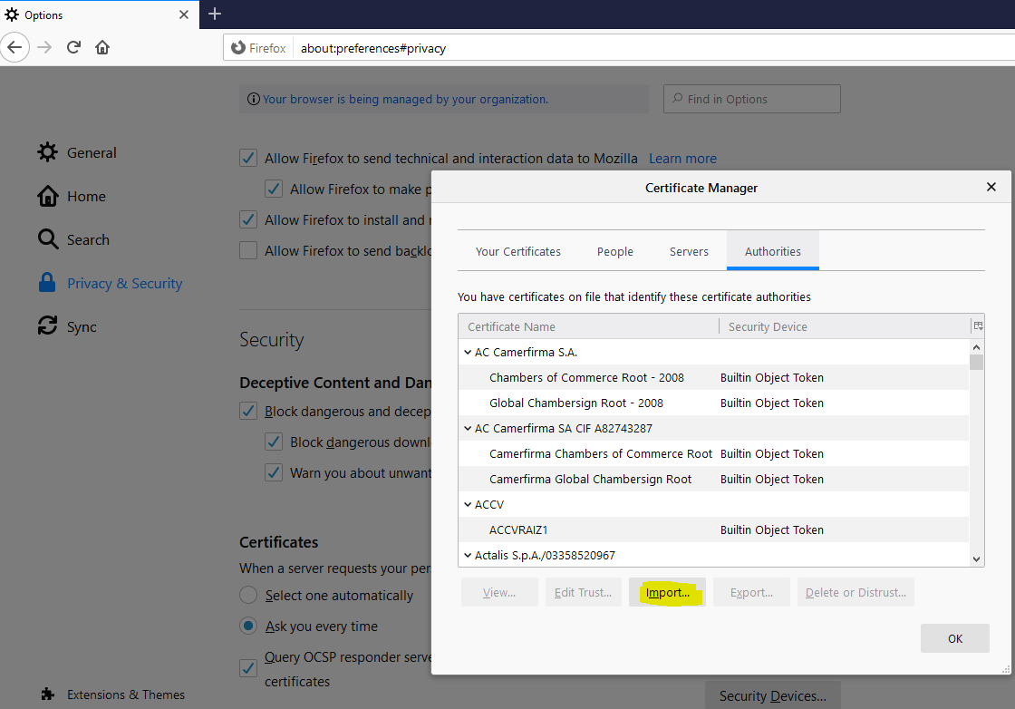

Configure users with RSA keys for access to Pfsense firewall over SSH

1. Create users {studentID}-ro and studentID}-rw and set passwords that meet complexity requirements
   1. List steps and provide screenshots

Create user with johan5257-ro and johan5257-rw

Create password: Password1

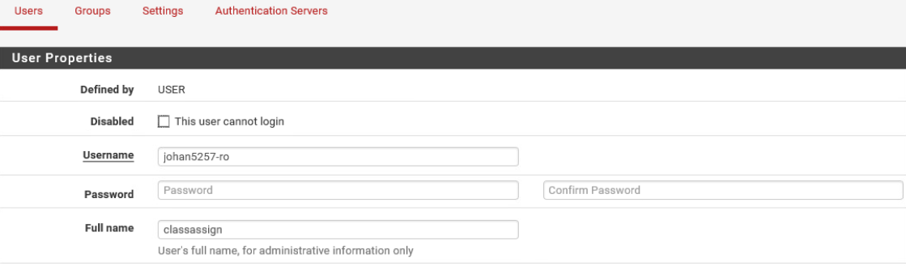

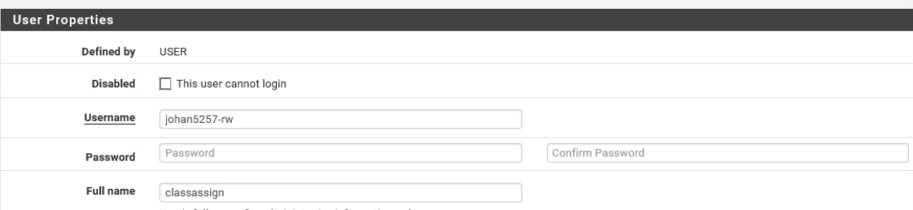

1. Generate RSA keys for new users (with no passphrase)
   1. List steps and provide screenshots
2. Type: ssh-keygen -b 4096 in powershell on Windows Server.
3. Go to C:\Users\Administrator/.ssh/id_rsa
4. Copy the content
5. On the pfSense firewall configurator, go to System > User Manager > Users
6. Paste into the RSA SSH key in the users Johan5257-ro/Johan5257-rw input for the SSH key.

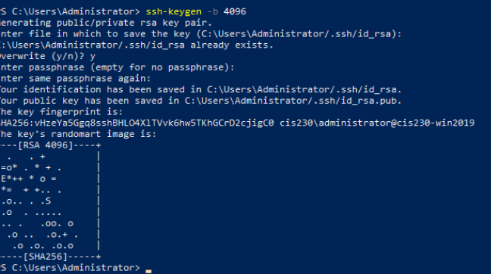

Configure sshd_config to allow public key authentication

1. List steps

To configure the `sshd_config` file to allow public key authentication, follow these steps:

Step 1: Open the SSH Daemon Configuration File

Use your favorite text editor to open the `sshd_config` file. You may need root privileges to edit this file.

```bash

sudo nano /etc/ssh/sshd_config

```

Step 2: Enable Public Key Authentication

Locate the following lines and make sure they are configured as shown:

```bash

# Ensure the following options are set to "yes"

PubkeyAuthentication yes

AuthorizedKeysFile .ssh/authorized_keys

```

If these lines are commented out (with a `#`), remove the `#` at the beginning.

Step 3: Disable Password Authentication (Optional but recommended for security)

To increase security, you can disable password authentication:

```bash

PasswordAuthentication no

```

### Step 4: Save and Exit

Press `CTRL + O` to save the file and `CTRL + X` to exit the editor.

### Step 5: Restart the SSH Service

Restart the SSH daemon to apply changes:

```bash

sudo systemctl restart sshd

```

Step 6: Check SSH Service Status

To ensure the SSH service is running without issues:

```bash

sudo systemctl status sshd

```

Step 7: Upload Your Public Key

Copy your public key to the server’s authorized keys file using the `ssh-copy-id` command:

```bash

ssh-copy-id user@server_ip

```

Step 8: Test the Configuration

Try logging in to your server via SSH to ensure that public key authentication works:

```bash

ssh user@server_ip

```

You should be able to log in without being prompted for a password, provided your private key is loaded or accessible.

Pfsense Firewall Execution Plan: - logon to pfSense from Ubuntu

  Enable SSH access to firewall and change default port to 2022

1. List steps and provide screenshot

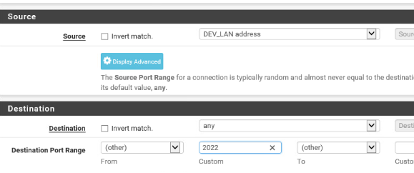 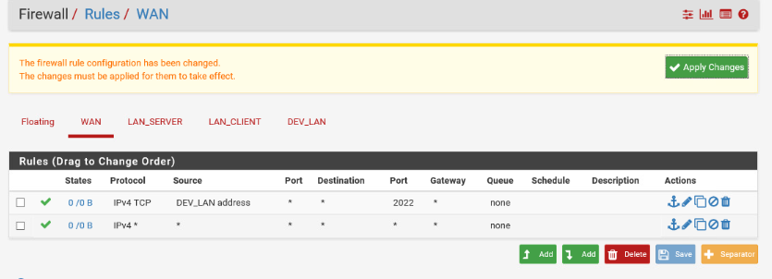

 Add SSH Keys for accounts {studentID}-ro and studentID}-rw for public key authentication

1. List steps and provide screenshot

Go to C:\Users\Administrator/.ssh/id_rsa

Copy the content

On the pfSense firewall configurator, go to System > User Manager > Users

Paste into the RSA SSH key in the users Johan5257-ro/Johan5257-rw input for the SSH key.

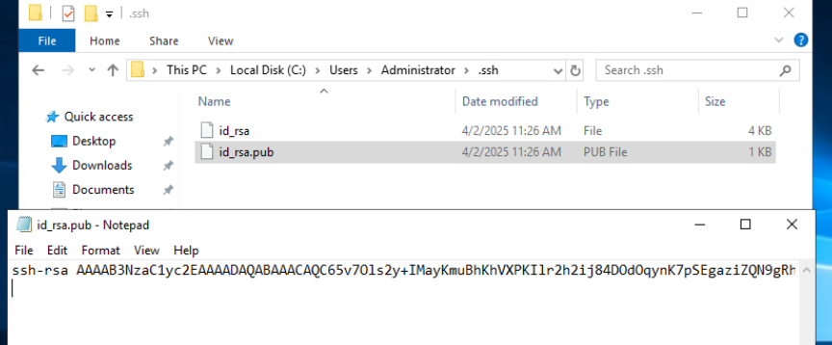

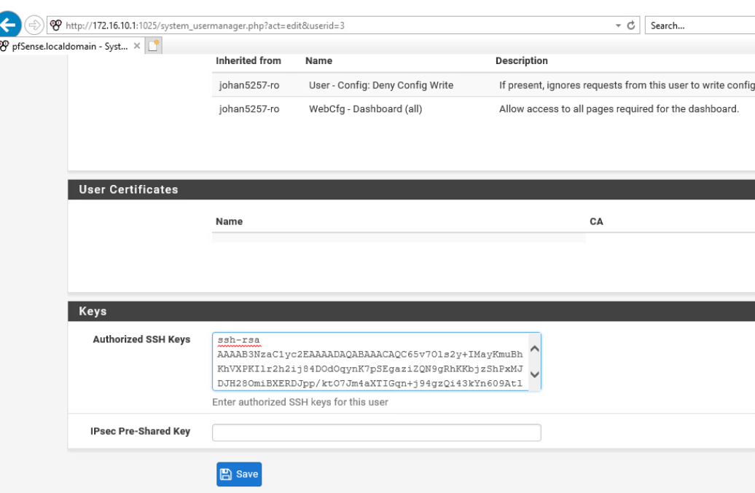 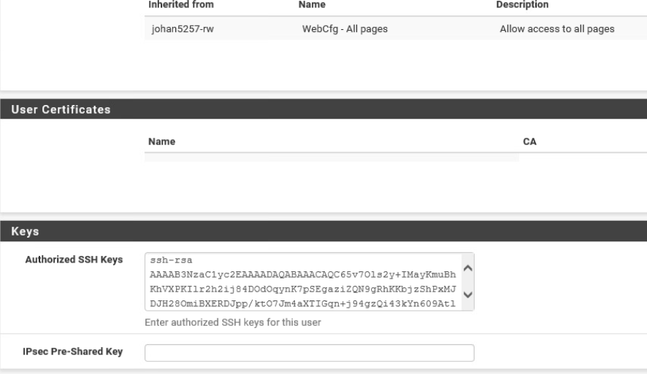

 Update firewall rules to allow Linux and port 2022

1. List steps and provide screenshot

Access Firewall Rules:

Go to Firewall → Rules → WAN.

Add a New Rule:

Click Add to create a new rule.

Rule Configuration:

Action: Pass

Interface: WAN

Address Family: IPv4 (or IPv4+IPv6 if applicable)

Protocol: TCP

Source: Any (or specify your Linux system’s IP/subnet)

Destination: This Firewall (self)

Destination Port Range: Custom, enter 2022

Description: Allow SSH on port 2022

Save and Apply Changes:

Click Save and Apply Changes.

Verify the Rule:

Go to Diagnostics → States and check if the rule is applied correctly.

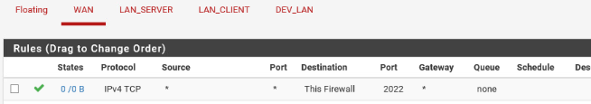

Windows Post-Execution and deliverables:

1. Log onto Window 10 client for screenshot showing the browser accessing the FQDN of the domain controller and shows as trusted site
2. On the Windows Server screenshots
   1. All configurations made through the CLI
   2. Logon to Linux server with password and then after with public key authentication enabled

Cannot Verify and Screenshot because the public key authentication was not successful and the instruction was not sufficient.

 Linux Post-Execution and deliverables:

1. Screenshots of all configuration changes made through the CLI
2. Screenshot showing generated RSA keys
3. Screenshot showing the browser accessing FQDN of the domain controller and shows as trusted site





These screenshot to verify connection to Windows Server’s IIS.

Screenshot for RSA was not provided because the instruction was not sufficient.

 Pfsense Firewall Post-Execution and deliverables:

1. Screenshots of firewall configurations

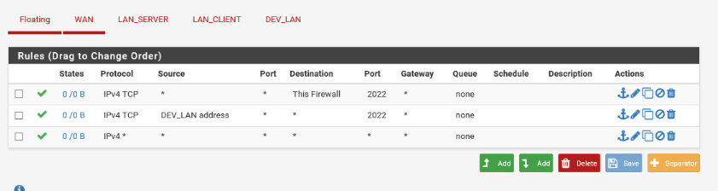

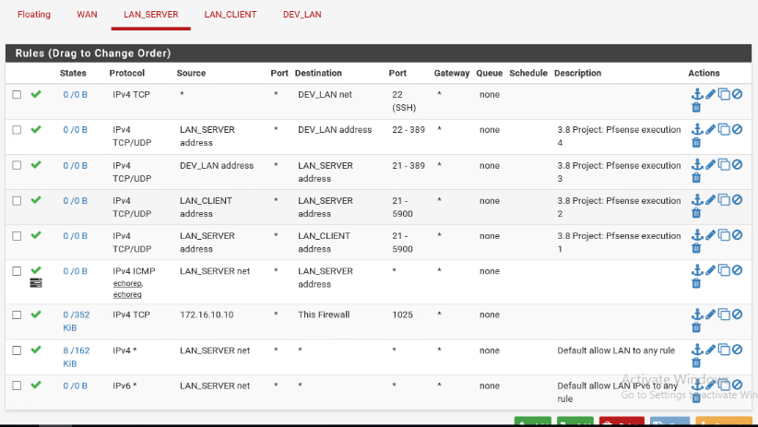

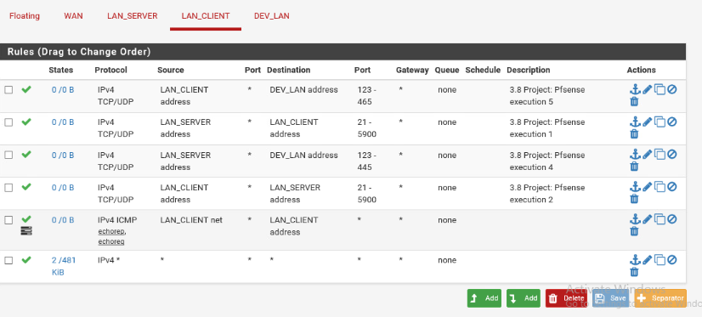

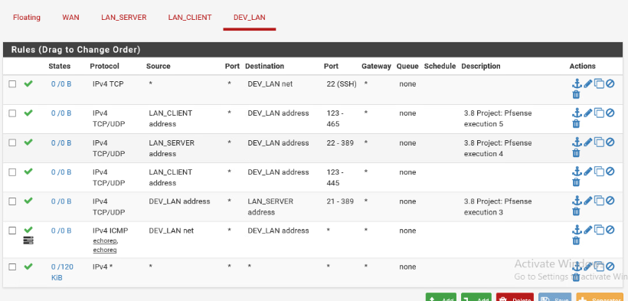

 

Follow-up

Update documentation for stakeholders

Progress Summary

Update project remediation plan with a summary of results and related audit findings that were remediated here:

The following Security Assessment Findings were remediated:

1. Configure Certification Authority Role on Windows Server
2. Configure RSA keys for Administrator and copy to Linux for public key logon
3. Add Windows CA certificate as a trusted Root CA
4. Configure users with RSA keys for access to Pfsense firewall over SSH
5. Configure sshd_config to allow public key authentication
6. Enable SSH access to firewall and change default port to 2022
7. Add SSH Keys for accounts {studentID}-ro and studentID}-rw for public key authentication
8. Update firewall rules to allow Linux and port 2022

System codes: LR – Linux Risk, WR – Windows Risk, FR – Firewall Risk

Submit to Canvas

Testing Procedures

Notify Validation Group environment is ready for testing.

Back out plan: revise each week as necessary. NOTE: List steps, do not execute.

Windows Server:

1. Revert settings to original values
2. Run a gpupdate /force

Linux System:

1. Disable firewall
   1. sudo ufw disable

Pfsense Firewall:

1. Revert configuration to previous version
   1. Diagnostics --> Config History --> select restore point and click 

Project notes  
Make sure you specify the systems that you are working on configuring as part of the change management process.

Server Info:

(Virtual) Server Name: CIS230-UBUNTU

OS: Ubuntu 9.4.0-1ubuntu1~20.04.2

IP Address: 172.16.30.30

Server Specs:

VM

CPU: Intel ® Xeon ® CPU E5-2640 v4 @ 240GHz

RAM: 1.9 GiB

STORAGE: 42.9 GB

NETWORK:

2 vCPU, 2GB RAM

(Virtual) Server Name: CIS230-WIN2019

OS: Windows Server 2019 Standard, 10.0.17763 Build 177763

IP Address: 172.16.10.10

Server Specs:

VM

CPU: Intel® Xeon ® CPU E5-2640 v4 @ 2.40GHz, 2397 Mhz, 2 Core(s), 2 Logical Processor(s)

RAM: 4.00 GB

STORAGE: 60 GB

NETWORK: Intel® 82574L Gigabit Network Connection

2 vCPU, 2GB RAM

(Virtual) Server Name: CIS230-WIN10

OS: Windows 10 Education, 10.0.10240 Build 10240

IP Address: 172.16.20.20

Server Specs:

VM

CPU: Intel® Xeon® CPU E5-2640 v4 @ 2.40GHz, 2397 Mhz, 1 Core(s), 1 Logical Processor(s)

RAM: 2.00 GB

STORAGE: 40.00 GB

NETWORK: Intel® 82574L Gigabit Network Connection

2 vCPU, 2GB RAM